

**Department of Computer Science and Engineering**

**Project Information**

Project name: Online Ordering System

(A web application for educational institution)

Course Code: CSE-436

**Supervisor**

**Akhlak Uz Zaman Ashik**

Senior Lecturer

Department of Computer Science and Engineering

Metropolitan University, Sylhet.

**Student Information**

|  |  |
| --- | --- |
| Name: Md. Jabed Hossain Sujel  ID : 181-115-034  Batch : CSE 44 | Name: Md. Rayhan Ahmed  ID : 181-115-013  Batch : CSE 44 |

**Acknowledgement**

First of all, we want to thank the almighty Allah for giving us the opportunity for completing and submitting the final year project on time. It would not be possible to submit the final year project without the blessing of almighty Allah. Also we would like to express our deepest appreciation to all those who provided us the possibility to complete this project.

A special gratitude we give to our project supervisor, **Akhlak Uz Zaman Ashik**, Whose contribution in stimulating suggestions and encouragement, helped us to coordinate our project.

We are sincerely grateful to out Head of the Department **Md. Mahfujul Hasan & respected faculty members** of Metropolitan University for sharing their truthful and illuminating views throughout these four years and for making us skilled and giving us the knowledge of Computer Science and Engineering.

Your contribution can only be acknowledgment but never be rewarded.

Many people, especially our batch mates have made valuable comment suggestions on this project, which gave us the inspiration to improve this project. We are also grateful to all of them.

**Certificate**

The undersigned here by certify that they have read and recommend to the controller of examination for acceptance of the project entitled- “Online Ordering System” By Md. Jabed Hossain Sujel (ID: 181-115-034) & Md. Rayhan Ahmed (ID: 181-115-013). It has been defended in front of the following members of the project committee on 2021. The members have accepted this project as the partial fulfillment of the requirement for the degree of Bachelor of Science (B.Sc) in Computer Science and Engineering (CSE).

|  |  |  |  |
| --- | --- | --- | --- |
|  | |  | |
|  | |  | |
|  | **Akhlak Uz Zaman Ashik**  Project Supervisor  Senior Lecturer,  Department of Computer Science and Engineering  Metropolitan University, Sylhet. | |  |

**Abstract**

The aim of the project is to implement an Online Ordering System (OOS) suitable for an online shop, providing flexibility to adapt to new and changing requirements. This Online Ordering System (OOS) is an automated version of the manual Online Ordering System (OOS) and using this software means securing the activities of the shopping system. The vision is to provide a progressive and expandable information service to viewers, customers and admin.

E-commerce refers to the purchase and sale of goods and/or services via internet. Online Ordering System is a part of e-commerce. ONLINE ORDERING SYSTEM (OOS) is a website designed primarily for use in the foods/medicines/clothes delivery. Through these services restaurants/ shopping malls/pharmacies can sell and distribute their resources at minimal resource usage effectively with high profits by gaining the customer trust. This Online Ordering System database will be helpful for the business owners to extend their business just by placing the orders online and not visiting the restaurants, shopping malls and pharmacies.

There is no confinement for placing and receiving the orders, since the order can be placed online. There will be no waiting time with the vast amount of verities at the comfortable prices. To develop this application database is the main part which will communicate through the application to retrieve the details.

In future, we will be creating the online ordering database with Oracle as a platform.

Database includes customers can place their orders from different categories like clothes, foods and medicines and staff will process the orders and deliver the requested order with an expected delivery time.

With this application, users or any organization can perform actions like,

1. Visitors will only be able to see product details but will not be able to order.
2. Customer registration (Login, Sign up)
3. Add to Cart by customers
4. Admin Log In
5. Product setup (Create, Edit, Active/Inactive)
6. Stock setup (Create, Edit, Active/Inactive)
7. Order setup (Edit, Receive/Pending/Rejected)
8. Invoicing system(Confirm/Cancle)
9. Message setup (send and view)
10. Product types setup (Create, Edit, Active/Inactive)
11. Brands setup (Create, Edit, Active/Inactive)
12. Roles (Create, Edit, Active/Inactive)

**TABLE OF CONTENTS**

**Contents**

**Chapter 1** 13

**Introduction** 13

1.1 Introduction 14

1.1.1 Visitor 14

1.1.2 Customer or User 14

1.1.3 Admin 14

1.1.4 Goal 14

1.1.5 Background of Project 15

1.2 Objective 16

1.3 Features 16

1.3.1 Before Login 16

1.3.2 For Admin 16

1.3.3 For Customers 17

1.4 Justification 17

1.5 Project Scope 17

1.6 Limitations of the System 18

1.7 Methodology of the Project Work 18

**Chapter 2** 19

**Feasibility Study** 19

2.1 Introduction of Feasibility Study 20

2.1.1 Technical Feasibility 20

2.1.2 Operational Feasibility 21

2.1.3 Economical Feasibility 21

2.1.4 Schedule Feasibility 22

**Chapter 3** 23

**Software Requirements Specification** 23

3.1 Introduction 24

3.2 Functional Requirements 24

3.2.1 Login Module 24

3.2.2 Administrator Module 25

3.2.3 Search Module 25

3.2.4 User Module 25

3.2.5 Authentication 26

3.2.6 Authorization 26

3.3 Non-Functional Requirements 26

3.3.1 Performance Requirements 26

3.3.2 Hardware Requirements 26

3.3.3 Software Requirements 26

3.4 Security 27

3.5 Error Handling 27

3.6 Availability 27

3.7 Ease of Use 27

**Chapter 4** 28

**System Design and Analysis** 28

4.1 Use Case Diagram 29

4.1.1 Use Case Diagram of the System 29

4.1.2 Use Case Diagram of the Admin 30

4.1.3 Use Case Diagram of the Customer 30

4.2 Activity Diagram 31

4.2.1 Activity Diagram of Admin 31

4.2.2 Activity Diagram of Customer 32

4.3 Entity Relationship Diagram 33

4.3.1 Objects 33

4.3.2 Entities 33

4.3.3 Attributes 34

4.3.4 Relation 34

4.4 Database Design

35

4.4.1 Fig: Database Design

36

4.4 Data Flow Diagram (DFD) 37

4.4.1 For Registration 37

4.4.2 For Login 38

4.4.3 For buying product 38

4.4.4 For Admin 39

4.4.5 For Customer 40

**Chapter 5** 41

**System Testing** 41

5.1 Introduction 42

5.2 Scope 42

5.3 Testing Goal 42

5.4 Confirmation Goal 42

5.5 Test Rules 43

5.6 Important things about Testing 43

**Chapter 6** 44

**Implementation & Maintenance** 44

6.1 Introduction 45

6.2 Education 45

6.3 Training 45

6.4 Implementation Schedule 45

6.5 Security 46

6.5.1 Security during Implementation

46

6.5.2 System Security Features 46

6.6 Implementation Support 46

6.7 Maintenance

46

**Chapter 7** 48

**Implementation Tools for the Project** 48

7.1 Tool’s 49

7.1.1 What is xampp? 49

7.1.2 What’s included in xampp? 49

7.1.2.1 Apache 49

7.1.2.2 MySQL 49

7.1.2.3 PHP 50

7.1.2.4 Perl 50

7.1.3 HTML 50

7.1.4 CSS 50

7.1.5 LARAVEL 51

7.1.6 VUE JS 51

7.1.7 MySQL 51

7.1.8 Vonage API 52

7.1.8.1 SMS API 52

7.1.8.2 Verify API 52

7.1.8.3 How it Works? 53

7.1.9 Nexmo SMS Provider 54

7.1.9.1 Send an SMS 54

**Chapter 8** 55

**User Interface** 55

8.1 Visitors 56

8.1.1 Home Page 56

8.1.2 Product Information 57

8.2 Customers 58

8.2.1 Registration Form 58

8.2.2 Verification 58

8.2.2.1 Email Verification 59

8.2.2.2 SMS Verification 59

8.2.3 Log In 60

8.2.4 Customer Home Page 61

8.2.5 Add to Cart 62

8.2.6 Shipping Address 62

8.2.7 Checkout 62

8.3 Message 63

8.4 About Authors 63

8.5 Admin 64

8.5.1 Log In 64

8.5.2 Dashboard 64

8.5.3 Product’s 65

8.5.4 Product Edit 66

8.5.5 Product Add 66

8.5.6 Stocks 67

8.5.7 Stock Edit 68

8.5.8 Stock Add 68

8.5.9 Order’s 69

8.5.10 Order Edit 69

8.5.11 Invoice 70

8.5.12 Product Categories 70

8.5.13 Product Categories Edit 71

8.5.14 Product Categories Add 71

8.5.15 Brands 72

8.5.16 Brands Edit 72

8.5.17 Brands Add 73

8.5.18 Rules 73

8.5.19 Rules Edit 74

8.5.20 Rules Add 74

8.5.21 Messages 75

8.5.22 Message View 75

**Chapter 9** 76

**Future plan** 76

9.1 Future Plan 77

**Chapter 10** 78

**Conclusion** 78

10.1 Conclusion 79

**Reference** 80

**Chapter 1**

**Introduction**

* 1. **Introduction**

Life of 21st century has become dependent on Technology. People become frequent with the usages of internet and software. They are searching for new facilities. Day to day this demand of new facilities are increasing tremendously. The World Wide Web (WWW) is contributing greatly for the creation of huge information database. Web based software are creating a new dimension in this modern world of technology.

The goal of this project is to create a system to maintain the details of products of our shop. It makes easier to maintain the product details than the manual system. We named it **RJ FASHION ONLINE SHOPPING.**

As it is an online platform we categorized our users in three section.

* + 1. **Visitor**

Who visited our site for various need and at the same time gather current product information and if they want to add more details they share their view.

* + 1. **Customer or User**

User who always use our service. We include a system so that our user can register to our platform and we mention them as registered member or our customer.

* + 1. **Admin**

Admin represents the key role in our platform. He have the authority to control the whole system and perform the necessary tasks. For Example: Product management, Order, Maintaining categories list etc.

* + 1. **Goal**

Shopping has long been considered a recreational activity by many. Shopping online is no exception. The goal of this application is to develop a web based interface for online retailers. The system would be easy to use and hence make the shopping experience pleasant for the users. The goal of this application is

1. To develop an easy to use web based interface where users can search for products, view a complete description of the products and order the products.
2. A search engine that provides an easy and convenient way to search for products specific to their needs. The search engine would list a set of products based on the search term and the user can further filter the list based on various parameters.
3. A Vue.js enabled website with the latest Vue.js controls giving attractive and interactive look to the web pages and prevents the annoying post backs.
4. A user can view the complete specification of the product along with various images.
   * 1. **Background of Project**

Now we will explain how our platform support the user and how it works.

As it represent online shopping system so product buyer and seller are the main character playing key role here. If one have to take our service as a user or customer he must have to register in our site with the necessary information and for that we will use a login form for our user. It provide us the opportunity to know about user and at the same time it add safety in our platform.

As a registered customer one will find his profile in our platform or site and he will have the options or facilities to place order, buy product and to checkout system that we have placed in our platform.

In today's world for safe and secure business we need our payment record so we will introduced an advanced system in our platform that provide payment invoice to user immediately after making checkout in our platform.

We will also give our user the opportunity to share their message in our platform and in many conditions they have the right to logout from our platform.

To run our platform an administration needed and an admin can play the role. We will introduce the system in our platform so that the admin manage the product categories (Food, Clothe, and Medicine etc.) included in our platform. Moreover manages to stock a variety of brands, product types and products.

Admin will also have the ability to manage orders and he confirms the sells. In certain conditions admin can change the Login System information to provide safety to our platform it indicates the admin panel logout or changing our platform login password. To make our platform more effective we are determined to give our best in making our project.

* 1. **Objective**

The objective of project on Online Ordering System (OOS) is to developing a WEB based automated system, which will cover all the information related to the all products which is used in our daily life. For example – Food, Clothes, Medicine Items and many more. So by this WEB based automated system a user want to purchase something then it only a mouse click away to purchase these products. The main objective of the project is to learn and implement a real-time application on database for Online Ordering System (OOS). This Database will be a great solution for many start-up online ordering business, they can just start initially with less funds by posting their menu online with this application.

* 1. **Features**

**1.3.1 Before Login**

1. Visitors (Who can see only products information)
2. Login
3. Register
4. Administrator login
5. About us
6. Contact us
   * 1. **For Admin**
7. Edit website details
8. Home (Shows where there are products, orders, messages and categories)
9. Admin Login
10. Order report (Where admin can see the complete list of what the customers ordered.)
11. Price cart management
12. Product setup (Create, Edit, Active/Inactive)
13. Stock setup (Create, Edit, Active/Inactive)
14. Invoicing system
15. Message setup
16. Product types setup (Create, Edit, Active/Inactive)
17. Brands setup (Create, Edit, Active/Inactive)
18. Roles (Create, Edit, Active/Inactive)

**1.3.3 For Customers**

1. Customer registration (Login, Sign up)
2. Login to site (When a customer can order something, he/she must fill in the register form and login. After login he/she will be able to order, otherwise no.)
3. My Cart ( Where user manage his order like: Edit, delete, add more products)
4. Buy products (Categories: Controlled by admin. Which can be added it dynamically according to their needs.)
5. Checkout
6. Show products information
7. Shopping more
8. Shipping Address
9. Logout

**1.4 Justification**

1. To ensure the efficiency of the system by proving better services compared to previous technologies.
2. To ensure efficiency by providing information.
3. To ensure the user by providing better facilities.
4. To ensure an easier way to get all the information on a mobile.

**1.5 Project Scope**

This project will reduce the sufferings of the user of a business institution’s, to maintain day to day basic operations within a less consuming time. On the other hand a user of the application will also get a user friendly interface along with maintain his/her information. In fact user can control the whole system.

This website can be used by any e-commerce site to maintain the user records, daily transactions, products management etc. There are other opportunities as well:

1. User login
2. Facility to reserve products that are available
3. A status pages for all users to view products ordered by them
4. Facility to cancel the ordering process
5. A status pages for admin to view currently registered customers
6. Shopping cart module starts when the user views the shopping cart. All the products that have been added to the shopping cart by the user are listed along with their price and the quantity. The total price of all the products added to cart is displayed. A user can edit the quantity of each product or remove the product from the shopping cart. A user can remove the product from the cart by clicking a button. The total price changes accordingly when a user edits the quantity of a product or when a product is removed from the cart.
7. Admin login
8. Users can have multiple shipping and billing information saved. Also the checkout.
9. The project is economically feasible as the only cost involved is having a computer with the minimum requirements mentioned earlier. For the users to access the application, the only cost involved will be in getting access to the Internet.
10. Admin can management products details like: create, edit, view, deleted products.

Finally this system will provide data accuracy and security to all users of the system.

**1.6 Limitations of the System**

1. The user of the system must be computer literate and familiar with web application uses.
2. A machine with any computer OS with web browsers needed to use this application.
3. Requires internet connection for using this project.
4. Users must be registered.

**1.7 Methodology of the Project Work**

The methodology for developing the application was into different components. Which are given below,

1. Data study and analysis.
2. Building Entity-Relationship Diagram.
3. Data normalization and Table Design.
4. Database Creation.
5. Application and Interface Design Coding, Error Handling and Debugging.

**Chapter 2**

**Feasibility Study**

**2.1 Introduction of Feasibility Study**

Feasibility study is the beginning investigation for any software development. Simply a feasibility study is a short focused study that will check whether the system can contribute to overall objectives. It also justify whether the system can be developed using current technology and schedule. Feasibility study also checks the integration of the system with other system that is already in place. It assesses the technical, economic, schedule and operational merits of a project. From the perspective of Systems analyst Feasibility analysis is a primary tool for recommending whether proceed to the next phase or discontinue the project. In this chapter we will able to know the Feasibility of the proposed system.

We will consider 4 types of feasibility study, they are:

1. Technical Feasibility
2. Operational Feasibility
3. Economic Feasibility
4. Schedule Feasibility

**2.1.1 Technical Feasibility**

Technical Feasibility focused on present technical resources of the organization and their applicability to the expected needs of the proposed system. Technical Feasibility is an evaluation of the software and hardware and justifies how it meets the need of the proposed system. If the technical capacity of the proposed system is sufficient to support the project requirements then the system will considered technically feasible.

Technical Feasibility aims to answer the following questions:

1. Does the system fulfill the requirement of hardware and software?
2. Are the current Technical resources sufficient for the new system?
3. Is the project feasible within the limit of current technology?
4. Does the technology exist?
5. Is there enough man power like coder, tester and debugger?
6. Is the system fulfilling practical criteria?
7. Is it available within the resource constrains?
8. Can the system be upgraded?

The answer of the above questions for the proposed system is yes. It fulfills all the criteria of Technical Feasibility. So the proposed project is technically feasible.

**2.1.2 Operational Feasibility**

Operational Feasibility measures how well a proposed system solves the problems, and takes advantage of the opportunities identified during scope definition and how it satisfies the requirements identified in the requirements analysis phase of system development. It also Justify how well the project will support the customer.

Operational Feasibility aims to answer the following questions:

1. Is the project feasible to operate?
2. Will the system affect the users in considerable way?
3. Does the current mode of the operation provide adequate throughput and response time?
4. Does the current mode operation offers effective protection against accuracy and security of system data?

The answer of the above questions for the proposed system is yes. It fulfills all the criteria of Operational Feasibility so the proposed project is operationally feasible.

**2.1.3 Economical Feasibility**

Economic Feasibility assesses the viability, cost and benefits of projects before financial resources are allocated. Economic Feasibility also ensures the economic benefits of the organization. Economic Feasibility involves benefits and evaluation of effectiveness of the proposed system.

Economic Feasibility aims to answer the following questions:

1. Is the system can be developed within the estimated cost?
2. Is the system cost effective?
3. Will the proposed system give economic benefits to the organization?

The answer of the above questions for the proposed system is yes. It fulfills all the criteria of Economic Feasibility.

**2.1.4 Schedule Feasibility**

Schedule Feasibility estimates how much time the system will take to complete. It justify that if the project can be completed within time or not. Schedule Feasibility is the most important term in Feasibility study. A project will not success if it fails Schedule Feasibility.

Schedule Feasibility aims to answer the following question:

1. Can the project be completed within given time?

The answer of the above questions for the proposed system is yes. It fulfills all the criteria of Schedule Feasibility.

Finally from the above discussion it clear that the proposed system is feasible for proceeding into next phase as the proposed system fulfills all the criteria of technical, operational, economic and schedule feasibility.

**Chapter 3**

**Software Requirements Specification (SRS)**

**3.1 Introduction**

Software Requirement Specification (SRS) stands for Software Requirements Specification, which is a document that fully describes the expected behavior of a software system. Software Requirement Specification (SRS) is a process under the software requirement engineering process. This is the next phase after feasibility study in software requirement engineering process. It is a comprehensive description of the intended purpose and environment for software under development. Software requirement specification laying out functional and non-functional requirements and may include a set of use cases that describe interactions the users will have with the software. The Software requirement specification (SRS) fully describes what the software will do and how it will be expected to perform.

**3.2 Functional Requirements**

Functional requirements define the fundamental actions that must take place in the software in accepting the inputs and in processing and generating the outputs. These are listed as “shall” statements starting with “The system shall….

**3.2.1 Login Module**

This module is provided for administrator and users such as Product buyer and seller who have registered themselves in the system. These login are provided according to the need of the systems.

* **Input** – The user can log in to “Online Ordering System” with his/her valid email and password.
* **Process** – After entering user email and password by user process of validation occur to identify whether user email and password is available in database or not.
* **Output** – Registered user can access website and can use the services.

**3.2.2 Administrator Module**

The administrator is provided with password and login-id with which he/she can access the system. Administrator is provided right of maintaining the database, verifies registered users.

* **Input** – The user can log in to “Online Ordering System” with his/her valid email and password.
* **Process** – Process of validation will occur.
* **Output** – Administrator will maintain the database and will perform product seller process.

**3.2.3 Search Module**

In this module we are going to provide facility for Product buyer to search for Products according to their specified categories so that users can search for Products easily.

* **Input** – Initial word of Product, with the help of keywords and with the help of Brand name.
* **Output** – Information about Products.

**3.2.4 User Module**

As users are the main visitor of site, the following facilities are available through this module. - Can search the Products according to their need. - Can order online products and checkout. - Can get information about Products. - Can send a message to the admin panel.

* **Input** – The user can log in to “Online Ordering System” with his/her valid email and password.
* **Process** – Process of validation will occur.
* **Output** – Only genuine user can access services provided by website.

**3.2.5 Authentication**

1. **Login**- The user can log in to “Online Ordering System” with his/her email number and password.
2. **Logout**- The user can log out from the “Online Ordering System” system.
3. **Login failure**- If the user does not exist in the database.

**3.2.6 Authorization**

1. **User role check**- After logging in, the user role will be checked from the database and the user interface will be displayed according to their role.

**3.3 Non-Functional Requirements**

**3.3.1 Performance Requirement**

1. There is no restriction on the number of users to be added to the database.

**3.3.2 Hardware Requirements**

1. Processor: 2 GHz or above,
2. RAM: 4GB or above,
3. Storage: 1TB or above,
4. Internet connectivity.
5. Input device: Keyboard, Mouse
6. Output device: Monitor

**3.3.3 Software Requirement**

The system Software requirements are given below:

1. Operating System: Any computer operating system,
2. Browser: Any Browser with java script enabled.
3. Frontend Framework: jQuery, VueJS, Bootstrap 4
4. Backend Language: PHP (Laravel)
5. Database: MySQL
6. Local Host: Xampp (Version 7.2.0)

**3.4 Security**

The system provides email and password to prevent the system from unauthorized access.

**3.5 Error Handling**

An error should be considerably minimized and an appropriate error message that guides the user to recover from an error should be provided.

**3.6 Availability**

The system should always be available for access at 24 hours, 7 days a week.

**3.7 Ease of Use**

The system provides a navigation drawer in all interfaces except Login page for the user to interact with the application. The user can understand the features and activities by opening the navigation drawer. The user will get their Email address at the top of the navigation drawer.

**Chapter 4**

**System Design and Analysis**

**4.1 Use Case Diagram**

Use case diagram is the most known diagram type. A use case diagram is the simplest representation of a user's interaction with the system that shows the relationship between the user and the different use in which the user is involved. A use case diagram can identify the different types of users of a system. Use case diagrams give a graphic overview of the actors involved in a system, different functions needed by those actors and how these different functions interact. Use case diagram include use cases, actors, includes relationship, extended relationship and system boundary. A use case represents a function or an action within the system. Actor in a use case diagram is any entity that performs a role in one given system. The use case diagram of the system is given below.

**4.1.1 Use case diagram of the system**

Visitors

Customers

Admin

**4.1.2 Use case diagram of the admin**

Admin

**4.1.3 Use case diagram of the customer**

Customer

**4.2 Activity Diagram**

The activity diagram is basically a flow chart to represent the flow from one activity to another activity. The activity can be described as an operation of the system. It can be used to describe business workflow or the operational workflow of any component in a system. The activity diagram is given below

**4.2.1 Activity diagram of admin**

The administrator has all the rights to access the system. He is the one who has all rights to view the rules and product details, modify those details. He can add various product based on the category. He can also set the available quantity, brands of a product and its reasonable price. Also he can set discount in various occasion. Admin can also view the details of a messages. The admin have the power to generate the invoice so that users can also use the checkout to buy various product.

**4.2.2 Activity diagram of customer**

The customer can log in to the system by using his specific email and password. Customer can view the products and order the products according to their own needs. He can update his personal information by shipping address into the system. User can find various product by using search option easily.

**4.3 Entity Relationship Diagram**

Entity relationship diagrams are a way to represent the structure and layout of a database. It is used frequently to describe the database schema. ER diagrams are very useful as they provide a good conceptual view of any database, regardless of the underlying hardware and software. An ERD is a model that identifies the concepts or entities that exist in a system and the relationships between those entities. An ERD is often used as a way to visualize a relational database: each entity represents a database table, and the relationship lines represent the keys in one table that point to specific records in related tables.

ERDs may also be more abstract, not necessarily capturing every table needed within a database, but serving to diagram the major concepts and relationships. This ERD is of the latter type, intended to present an abstract, theoretical view of the major entities and relationships needed for management of electronic resources. It may assist the database design process for an e-resource management system, but does not identify every table that would be necessary for an electronic resource management database.

**4.3.1 Objects**

There are three main objects on an ER Diagram:

1. Entities
2. Attributes
3. Relation

**4.3.2 Entities**

An entity is a concept or object in the database. Entities are concepts within the data model. Each entity is represented by a box within the ERD. Entities are abstract concepts, each representing one or more instances of the concept in question. An entity might be considered a container that holds all of the instances of a particular thing in a system. Entities are equivalent to database tables in a relational database, with each row of the table representing an instance of that entity.

**4.3.3 Attributes**

The Supplier Name, Supplier Address, Telephone Number etc. A given attribute belonging to a given entity occurrence can only have one value. Therefore, if a supplier could have more than one address or telephone number then this should be determined before defining the attributes of that entity type. In this example the defined entity may require two or three address and/or telephone number attributes. It is the maximum practical instances of a given attribute that should be catered for in the entity type definition.

**4.3.4 Relation**

Relations are the connections between two or more entities. Relationship lines indicate that each instance of an entity may have a relationship with instances of the connected entity, and vice versa. Each entity type can always be described in terms of attributes, and these attributes will apply to all occurrences of that given entity type.

The Entity Relationship Diagram of the system is given below:

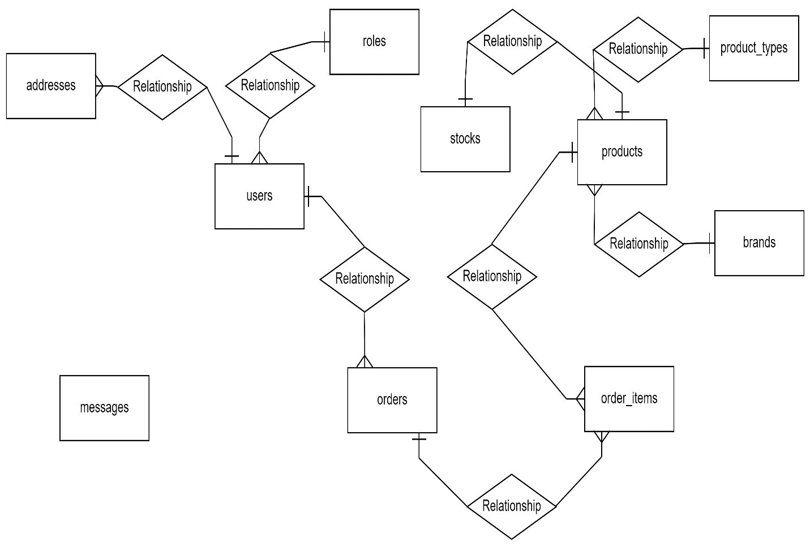

**4.4 Database Design**

Database is critical for all businesses. A good database does not allow any form of anomalies and stores only relevant information in an ordered manner. If a database has anomalies, it is affecting the efficiency and data integrity. For example, delete anomaly arise upon the deletion of a row which also forces other useful data to be lost. As such, the tables need to be normalized. This fulfils the last objective of ensuring data are accurate and retrieved correctly.

Database files are the key source of information into the system. It is the process of designing database files, which are the key source of information to the system. The files should be properly designed and planned for collection, accumulation, editing and retrieving the required information.

The organization of data in database aims to achieve three major objectives: -

1. Data integration
2. Data integrity
3. Data independence

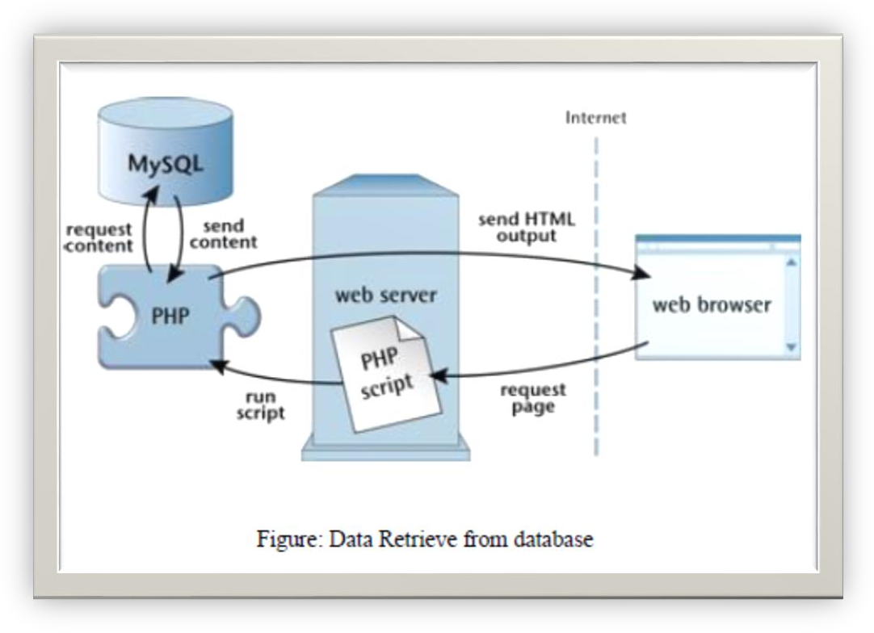

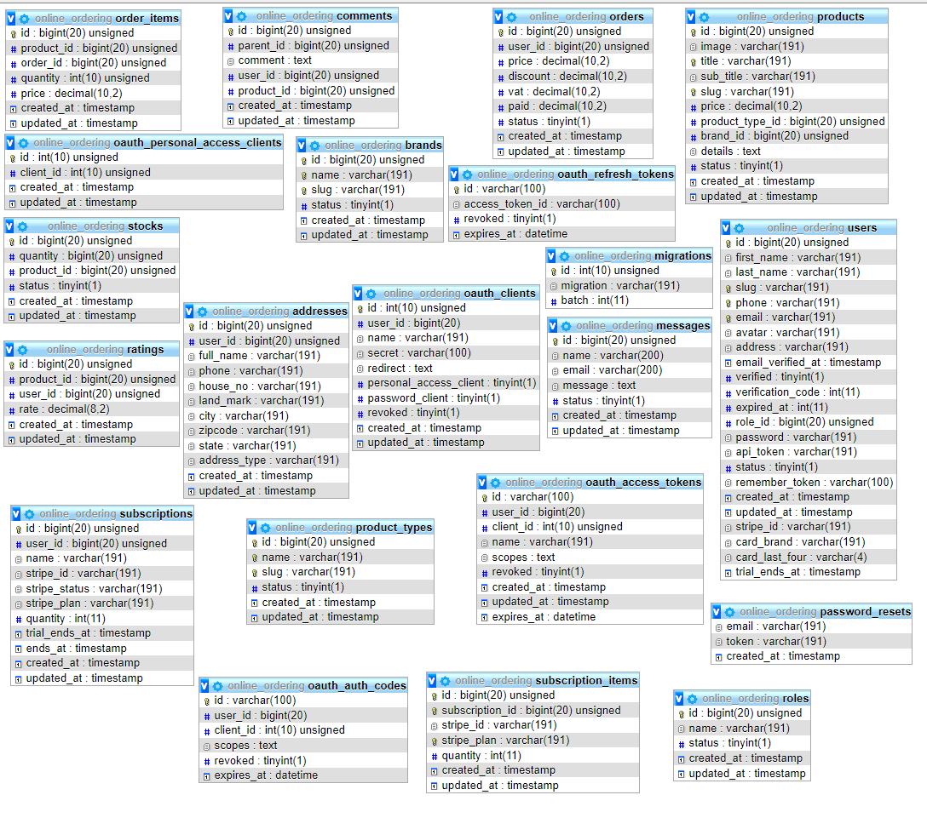

4.4.1 Fig: Database Design

**4.4 Data Flow Diagram (DFD)**

A data flow diagram is a structured analysis and design tool that can be used for flowcharting. A DFD is a network that describes the flow of data and processes that change or transform the data throughout a system. This network is constructed by using a set of symbols that don’t imply any physical implementation. It has the purpose of clarifying system requirements and identifying major transformations. So it is the starting point of the design phase that functionality decompose the requirements specifications down to the lowest level of detail. DFD can be considered to an abstraction of the logic of an information-oriented or a process-oriented system flow-chart. For these reasons DFD’s are often referred to as logical data flow diagrams.

**4.4.1 For Registration**

User

Details

Email Exists

Success

**4.4.2 For Login**

Access Denied

User Request

Not Authenticate

Authenticate

Buy Products

**4.4.3 For Buying Product**

User Request

User Cart

Checkout

**4.4.4 For Admin**

Product Details DB

Add

Products

Edit

Quantity

Stocks

Product Orders DB

View

Edit

Edit

Orders

Admin

Invoice

User messages DB

View

Messages

Log In

Print

Admin Details DB

Product Types DB

Add

Product types

Edit

Product Brands DB

Add

Brands

Edit

User Roles DB

Add

Roles

Edit

**4.4.5 For Customer**

Customer Details DB

Email

Login

Password

View

Search

Customer

Product Orders DB

Add to cart

Orders

Remove

Add more

Shipping address

Checkout

Customer messages DB

Send

Messages

**Chapter 5**

**System Testing**

**5.1 Introduction**

Software Testing is a process which tests whether the software meets the requirements and fulfills all the criteria or not. The system can be divided into two main categories they are Integrated Testing and Release Testing. Software testing involves the execution of a software component or system component to evaluate one or more properties of interest. In general, these properties indicate the extent to which the component or system under test:

1. Meets the requirements responds correctly
2. Perform functions successfully
3. Ensure usability
4. Can be run in its intended environments
5. Achieves the goals of requirements

The answer to the following question for this system is yes. All the functional works have checked and tested. After completing the testing process it has ensured that the software is running accurately and it has been fulfilled all the criteria of requirements.

**5.2 Scope**

The overall purpose of testing is to ensure the system meets all of its functional requirements. The purpose of this chapter is to describe the overall test plan and strategy for testing the system.

**5.3 Testing Goal**

The goals in testing this system include validating the quality, usability, reliability, and performance of the application. Testing will be performed from a black-box approach. Tests will be designed around requirements and functionality.

**5.4 Confirmation Goal**

Confirmation testing or re-testing: When a test fails because of the defect then that defect is reported and a new version of the software is expected that has had the defect fixed. In this case, we need to execute the test again to confirm whether the defect got actually fixed or not. This is known as confirmation testing and also known as re-testing. It is important to ensure that the test is executed in exactly the same way it was the first time using the same inputs, data, and environments.

**5.5 Test Rules**

1. Test every program statement and every path at least twice.
2. Test the most important and most heavily used parts of the programs most thoroughly.
3. Calculate the expected output before the test is executed.
4. Test modules individually before they are combined then test integration modules.

**5.6 Important things about Testing**

1. Test case needs to be simple and transparent.
2. Create a test case with End User in mind.
3. Avoid test case repetition.
4. Do not assume.
5. The test case must be identifiable.
6. Implement Testing Techniques.
7. Self-cleaning
8. Repeatable and self-standing.
9. Peer Review.
10. Fixed all bugs after collecting all test result.

**Chapter 6**

**Implementation & Maintenance**

**6.1 Introduction**

Implementation is next after testing. After a long explanation and building phases, the system is developed and tested. Implementation is the stage of the system development life cycle. The system is implemented into operation in a real environment. Formal acceptance typically terminates the implementation stage. After the implementation phase software development lifecycle is the most expensive and time-consuming. There are many ways of implementation. It must be decided which way to adopt prior to implementation. This phase required many things for consideration because a wrong approach could bring unexpected result. The risk associated with this phase should be sorted out. The typical advantages and disadvantages are also an important factor for implementation.

For front desk implementation method will be parallel and the new system will run parallel to the old one. Implementation is expensive because too many people are associated with the process it’s also time-consuming as the works are completed during implementation. Backup should be used. If any problem occurs and the system would not affected badly.

**6.2 Education**

It is essential for any system that the users of the system must know the context of the organization need. The user must be influenced by the benefits of a new system to them. The first and foremost decision in education and training must be about the operator to be educated and trained.

**6.3 Training**

The training phase is a phase where the users of the system train. In training the following methods can be used:

1. Observation
2. Informal Discussion
3. Computer Assisted Training
4. User Manual

**6.4 Implementation Schedule**

In this section, provide a schedule of activities to be accomplished during implementation. Show the required task in chronological order, with the beginning and end dates of each task.

**6.5 Security**

If appropriate for the system to be implemented, includes an overview of the system security features and requirements during the implementation.

**6.5.1 System Security Features**

In this section, provide an overview and discussion of the security features that will be associated with the system when it is implemented. It should include the primary security features associated with the system hardware and software.

**6.5.2 Security during Implementation**

This section addresses security issues specifically related to the implementation effort. For example, if LAN server will be installed at a site with sensitive data preloaded on non-removable hard disk drives, address how security would be provided for the data on these devices during shipping, transport, and installation because theft of the devices could compromise the sensitive data.

**6.6 Implementation Support**

Hardware, software, facilities and materials are needed. This section describes the support software, materials, equipment, and facilities required for the implementation as well as personnel requirements and training necessary for the implementation. The information provided in this section is not site-specific. If there are additional support requirements not covered by the subsequent sections, others may be added as needed. This section describes personnel requirements and any known or proposed staffing requirements, if appropriate. Also describe the training, if any, to be provided for the implementation.

**6.7 Maintenance**

Software maintenance must be performed to:

1. Correct faults
2. Improve design
3. Interface with other systems
4. Accommodation programs so that different hardware, software, system features, and telecommunication facilities can be used
5. Migrate legacy software and Retire software

**Types of maintenance**

In a software lifetime, the type of maintenance may vary based on its nature. It may be just a routine maintenance task as some bug discovered by some user or it may be a large event in itself based on maintenance size or nature. Following are some types of maintenance based on their characteristics:

1. **Corrective Maintenance:** This includes modifications and updates done in order to correct or fix problems, which are either discovered by the user or concluded by the user error reports.
2. **Adaptive Maintenance:** This includes modifications and updates applied to keep the software product up-to-date and tuned to the ever-changing world of technology and business environment.
3. **Perfective Maintenance:** This includes modifications and updates done in order to keep the software usable over a long period of time. It includes new features, new user requirements for refining the software and improving its reliability and performance.
4. **Preventive Maintenance:** This includes modifications and updates to prevent future problems of the software. It aims to attend to problems, which are not significant at this moment but may cause serious issues in the future.

**Chapter 7**

**Implementation Tools for the Project**

**7.1 Tool’s**

1. HTML
2. CSS
3. Bootstrap
4. Laravel
5. Vue.js
6. MySQL
7. XAMPP
8. Nexmo SMS Provider
9. Vonage API

**7.1.1 What is XAMPP?**

XAMPP stands for Cross-Platform (X), Apache (A), MySQL (M), PHP (P) and Perl (P). It is a simple, lightweight Apache distribution that makes it extremely easy for developers to create a local web server for testing purposes. Everything you need to set up a web server – server application (Apache), database (MySQL), and scripting language (PHP) – is included in a simple extractable file. XAMPP is also cross-platform, which means it works equally well on Linux, Mac and Windows. Since most actual web server deployments use the same components as XAMPP, it makes transitioning from a local test server to a live server is extremely easy as well. Web development using XAMPP is especially beginner friendly.

**7.1.2 What’s included in XAMPP?**

XAMPP has four primary components. These are:

**7.1.2.1 Apache**: Apache is the actual web server application that processes and delivers web content to a computer. Apache is the most popular web server online, powering nearly 54% of all websites.

**7.1.2.2 MySQL**: Every web application, howsoever simple or complicated, requires a database for storing collected data. MySQL, which is open source, is the world’s most popular database management system. It powers everything from hobbyist websites to professional platforms like Word Press.

**7.1.2.3 PHP**: PHP stands for Hypertext Preprocessor. It is a server-side scripting language that powers some of the most popular websites in the world, including Word Press and Facebook. It is open source, relatively easy to learn, and works perfectly with MySQL, making it a popular choice for web developers.

**7.1.2.4 Perl**: Perl is a high-level, dynamic programming language used extensively in network programming, system admin, etc. Although less popular for web development purposes.

**7.1.3 HTML**

Every webpage you look at is written in a language called HTML. You can think of HTML as the skeleton that gives every webpage structure. In this course, we'll use HTML to add paragraphs, headings, images and links to a webpage.

In the editor to the right, there's a tab called test.html. This is the file we'll type our HTML into. Like any language, it has its own special syntax. A browser's job is to transform the code in test.html into a recognizable webpage! It knows how to lay out the page by following the HTML syntax.

**7.1.4 CSS**

Cascading Style Sheets (CSS) is a style sheet language used for describing the presentation of a document written in a markup language.[1] Most often used to set the visual style of web pages and user interfaces written in HTML and XHTML, and is applicable to rendering in speech, or on other media. Along with HTML and JavaScript, CSS is a cornerstone technology used by most websites to create visually engaging webpages, user interfaces for web applications, and user interfaces for many mobile applications.

CSS is designed primarily to enable the separation of document content from document presentation, including aspects such as the layout, colors, and fonts.[3] This separation can improve content accessibility, provide more flexibility and control in the specification of presentation characteristics, enable multiple HTML pages to share formatting by specifying the relevant CSS in a separate .CSS file, and reduce complexity and repetition in the structural content.

**7.1.5 LARAVEL**

LARAVEL is a free open source PHP web frame work, created by Taylor Otwell and intended for the development of web applications following the model-view-controller architectural pattern and based on symphony.

LARAVEL attempts to take the pain out of development by easing common tasks used in the majority of web projects, such as authentication, routing, sessions, and caching.

LARAVEL aims to make the development process a pleasing one for the developer without sacrificing application functionality LARAVEL is a scripting language that is often used to develop a variety of web pages and Internet applications. Files that have the .LARAVEL extension can contain text, HTML tags and scripts. These files are processed by a remote server and are then returned to the user's Web browser as plain

**7.1.6 VUE JS**

Vue.js actually a java Script framework with various optional tools for building user interfaces. Vue.js is one of the new software technologies that are being widely used across the world for web development. It is an open-source java Script framework for building user interfaces and single-page applications.

Vue.js is a programming language that is run by most modern browsers. It supports object oriented programming and procedural programming. It can be used to control web pages on the client side of the browser, server-side programs, and even mobile applications. To write a Vue.js, you need a Web browser and either a text editor or an HTML editor. Once you have the software in place, you can begin writing JavaScript code. To add vue.js code to an HTML document, you need to create or open an HTML file with your text/HTML.

**7.1.7 MySQL**

1. MySQL is a database system used on the web.
2. MySQL is a database system that runs on a server.
3. MySQL is ideal for both small and large applications.
4. MySQL is very fast, reliable, and easy to use.
5. MySQL uses standard SQL.
6. MySQL compiles on a number of platforms.
7. MySQL is free to download and use.
8. MySQL is developed, distributed, and supported by Oracle Corporation.

**7.1.8 Vonage API**

Vonage is a communication platform as a service (CPaaS) provider for consumers and businesses that makes it possible for customers to connect and communicate on any device through cloud-hosted voice, video, chat and short message service (SMS), Vonage allows developers to integrate real-time messaging, voice and authentication into applications without having to building backend infrastructure through its Nexmo API platform.

The Vonage product portfolio supports collaboration, conferencing, online meetings and contact centers for small local businesses as well as corporate enterprises with distributed workforces. Offering include both bring-your-own-broadband (BYOB) cloud products and those that offer carrier-grade reliability and quality of service (QoS) through a private Multiprotocol Level Switching (MPLS) network, software-defined WAN (SD-WAN) for UCaaS technology and hybrid solutions. Vonage UCaaS integrates with many popular business applications.

**7.1.8.1 SMS API**

Vonage’s SMS API enables you to send and receive text messages to and from users worldwide using our REST APIs.

1. Programmatically send and receive high volumes of SMS globally
2. Send SMS with low latency and high delivery rates
3. Receive SMS using local numbers
4. Scale your applications with familiar web technologies
5. Pay only for what you use, nothing more
6. Auto-redact future to protect privacy

**7.1.8.2 Verify API**

The Verify API enables you to confirm that you can contact a user at a specific number, so that you can:

1. Reach your users at any time, by ensuring that you have their correct phone number
2. Protect against fraud an spam, by preventing one user from creating multiple accounts
3. Add an extra layer of security to help confirm a user’s identity when they went to perform certain activities

**7.1.8.3 How it Works?**

Verification is a two-stage process that requires two API calls:

**Verification Request**

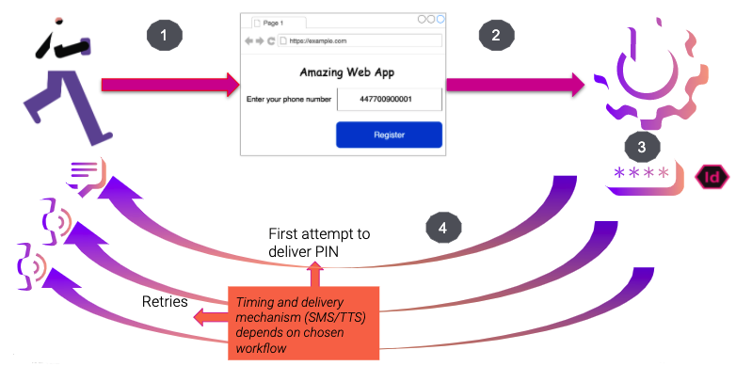

1. A user registers for your service via your app or web site and provides a phone number.
2. To confirm that the user has access to the number that they have registered with, your application makes an API call to the Verification request endpoint.
3. The Verify API generates a PIN code, with an associated request_id.

**!** *It is possible to supply your own PIN code in some circumstances, please contact your account manager.*

1. The Verify API then attempts to deliver this PIN to the user. The format (SMS or Text-to-speech (TTS)) and timing of these attempts are defined by your chosen workflow. If the user does not revisit your app or website to enter the PIN they have received, the verification request will ultimately time out. Otherwise, you need to verify the number that they entered by performing a Verification check.
2. The user receives the PIN and enters it into your application.
3. Your application makes an API call to the Verification check endpoint, passing in the request_id and the PIN that the user entered.

**Verification Check**

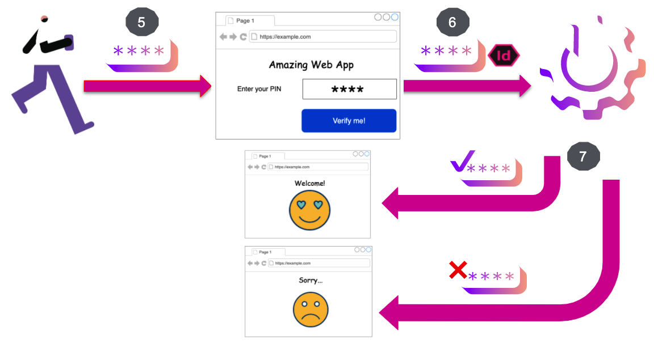

1. The Verify API checks that the PIN entered matches the one that was sent and returns the result to your application.

**7.1.9 Nexmo SMS Provider**

Nexmo is now part of Vonage. We are making communication more flexible, intelligent, and personal, to help enterprises the world over stay ahead. We provide unified communications, contact centers, and programmable communications APIs, built on the world’s most flexible cloud communications platform.

**7.1.9.1 Send an SMS**

This example shows you how to send an SMS to your chosen number. First, sign up for a Vonage account if you don’t already have one, and make a note of your API key and secret on the dashboard getting started page.

Replace the following placeholder values in the sample code:

|  |  |
| --- | --- |
| **Key** | **Description** |
| VONAGE_API_KEY | Your Vonage API key |
| VONAGE_API_SECRET | Your Vonage API secret |

**Chapter 8**

**User Interface**

**8.1 Visitor’s**

**8.1.1 Home Page**

Where viewers can see the product according to the category, brand and money range of their choice.

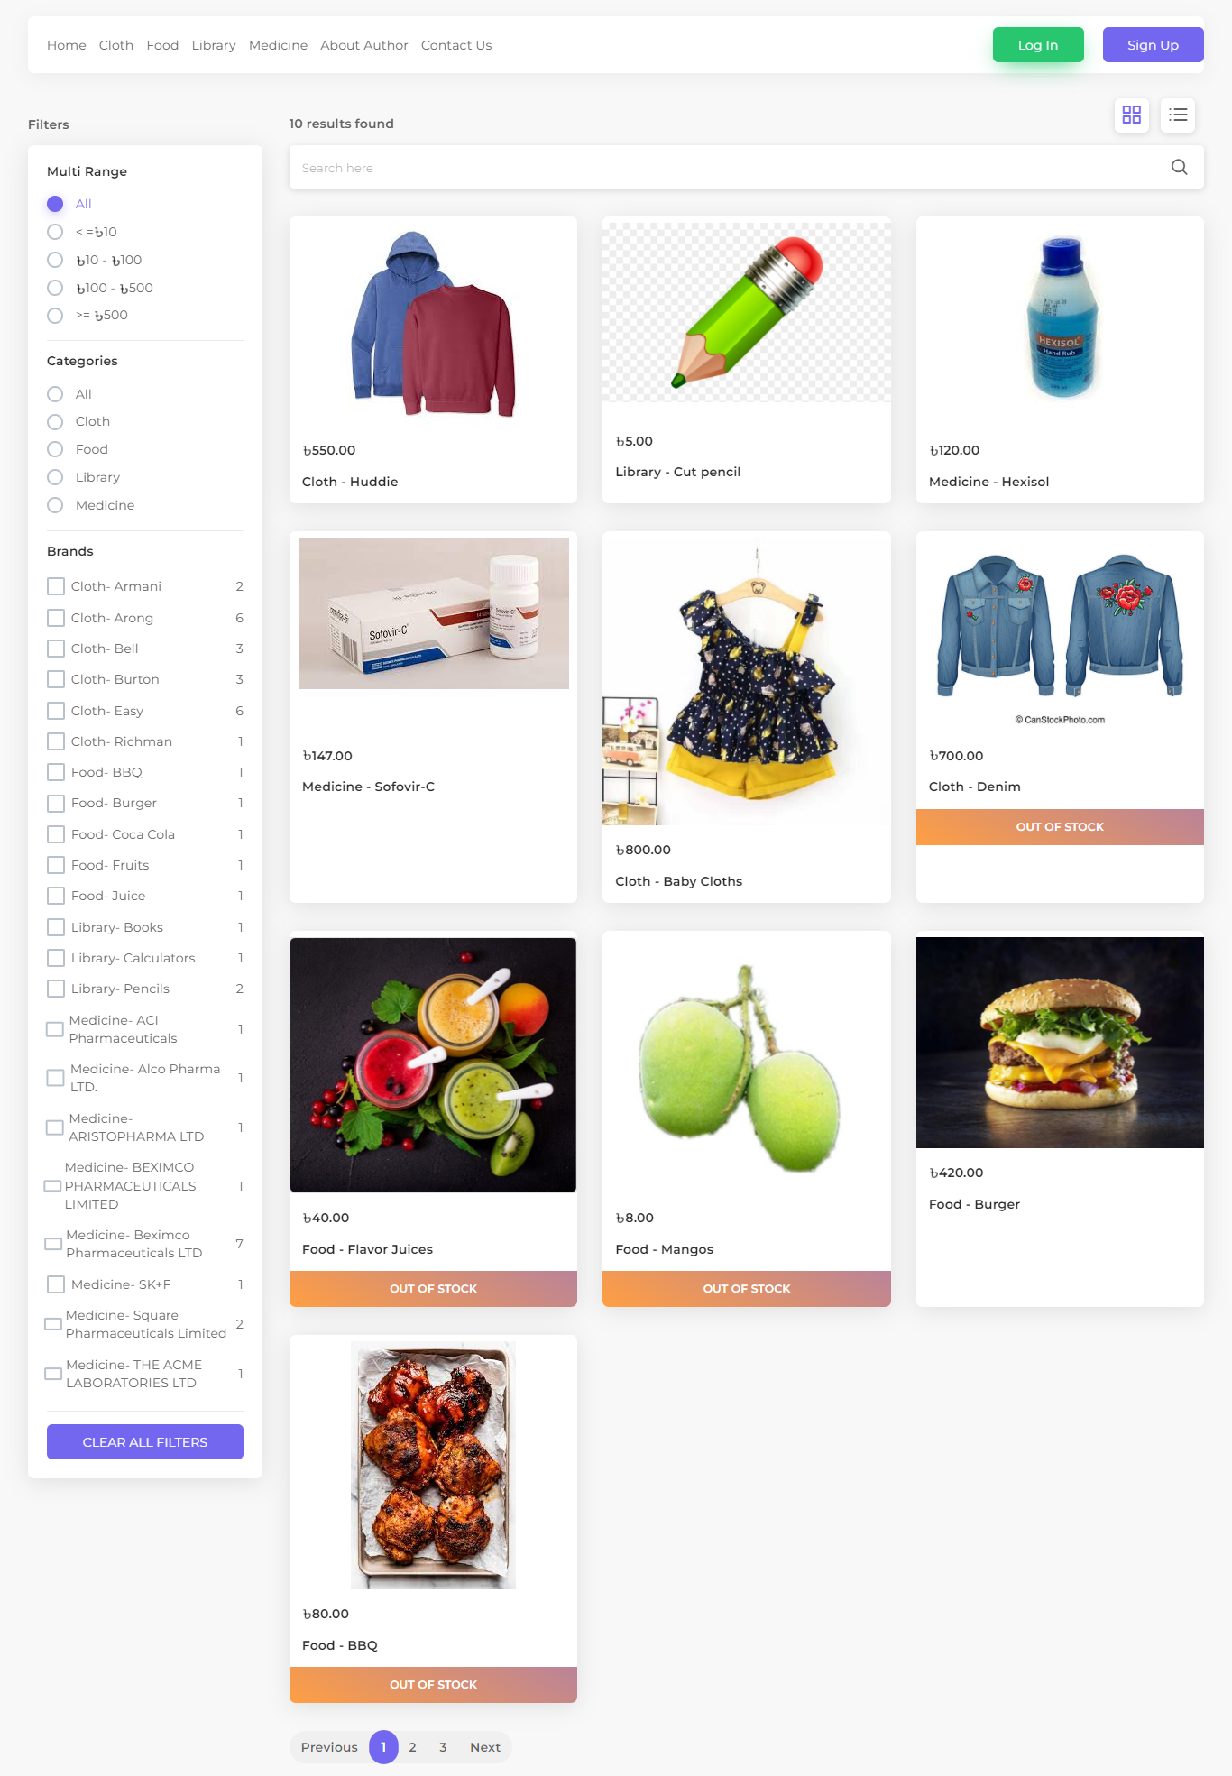

**8.1.2 Product Information**

Viewers can also view the product information and other related products according to their categories.

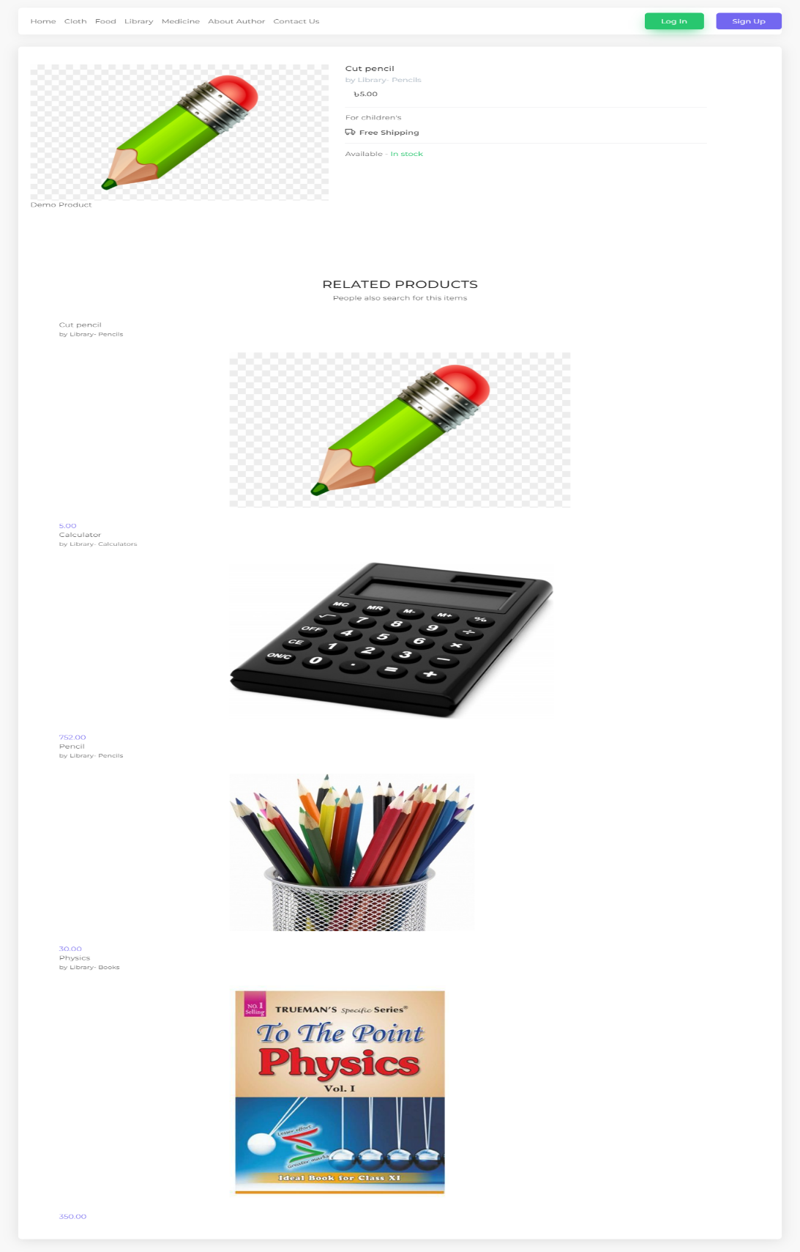

**8.2 Customers**

**8.2.1 Registration Form**

The customer must fill out the registration form to order anything.

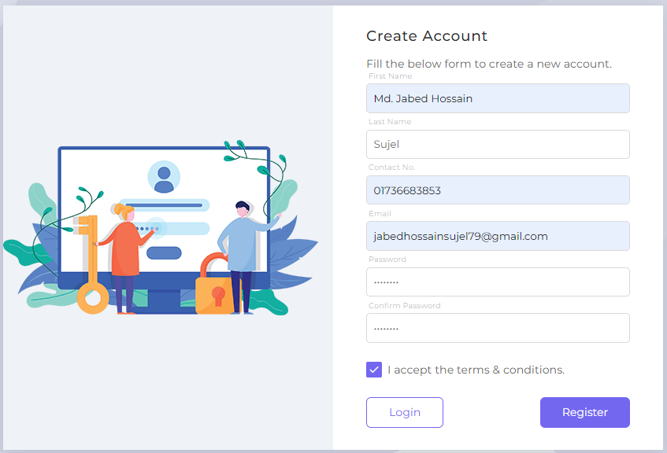

**8.2.2 Verification**

In this case a customer must give him valid email and registered numbers before registering. Otherwise, you will not be able to register.

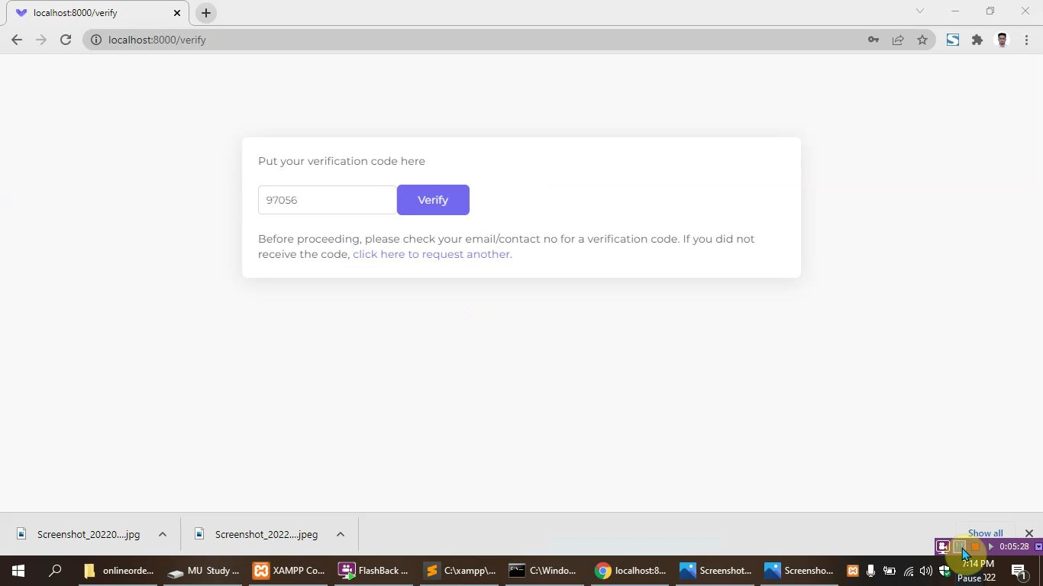

**8.2.2.1 Email Verification**

When a customer registers with his/her valid email, an email verification code will be sent to his/her email from our website.

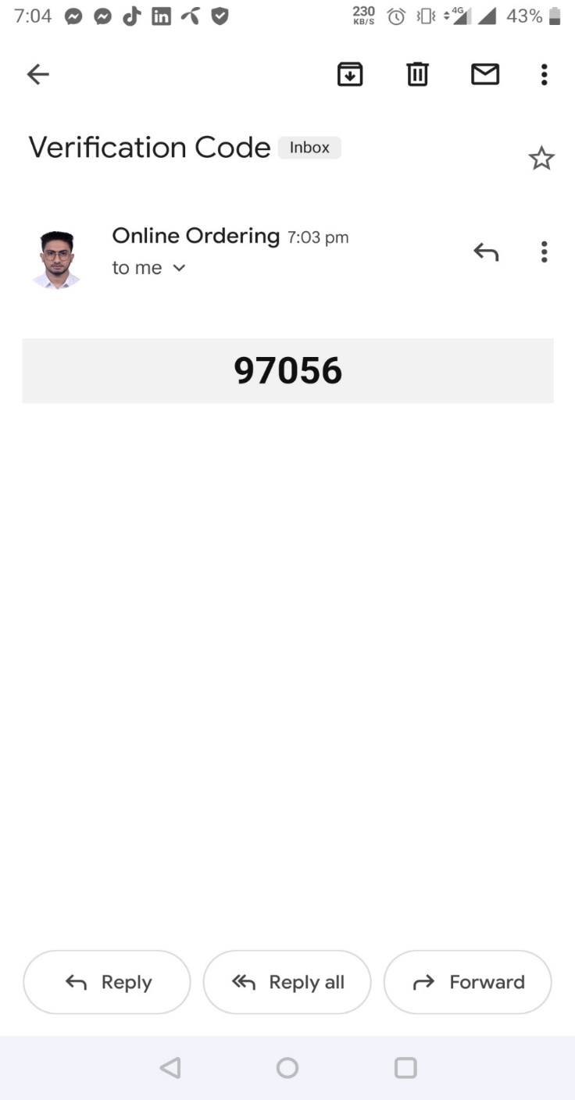

**8.2.2.2 SMS Verification**

When a customer registers with his/her registered number, an SMS verification code will be sent to his/her number from nexmo SMS provider.

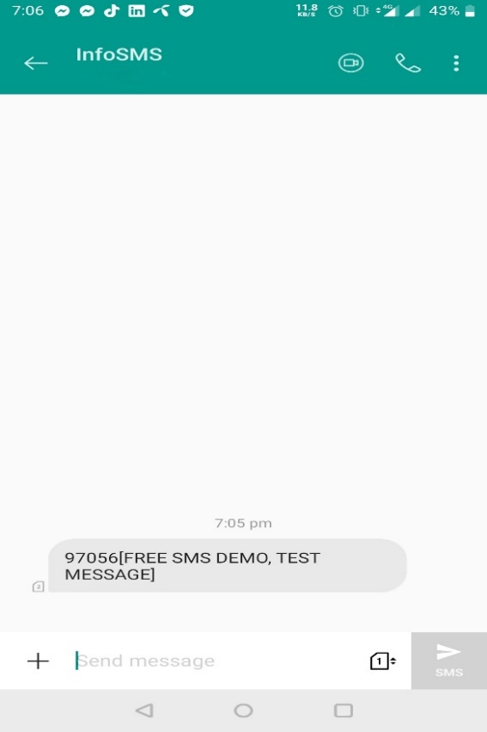

**8.2.2 Log In**

When the registration is completed, he/she has to login with correct email and password.

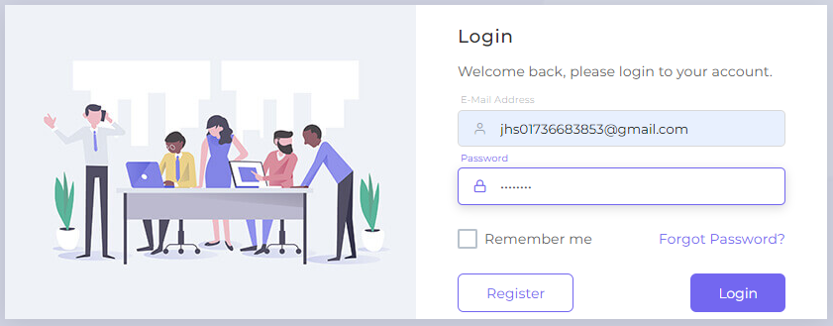

**8.2.3 Customer Home Page**

This type of interface will appear in front of the customer after login. Where he/she can find the information according to his/her choice and also know if it is in stock.

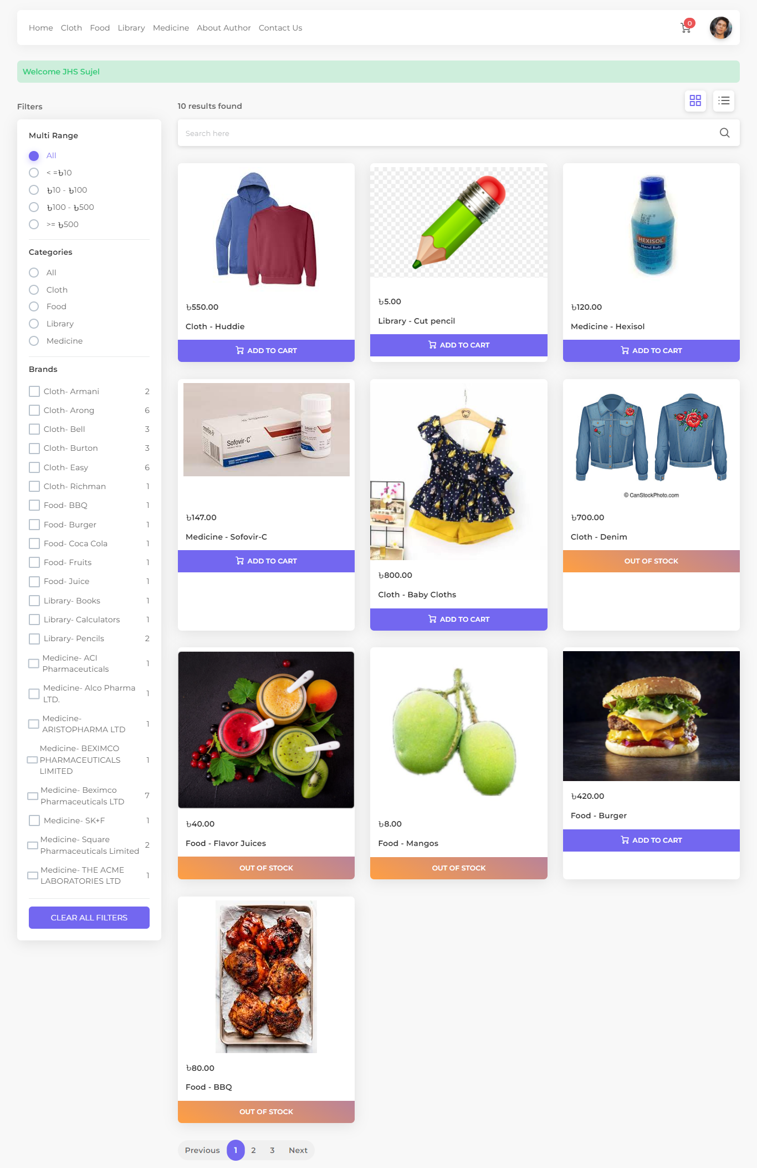

**8.2.4 Add to cart**

Customers will be able to add the product of their choice by clicking the mouse.

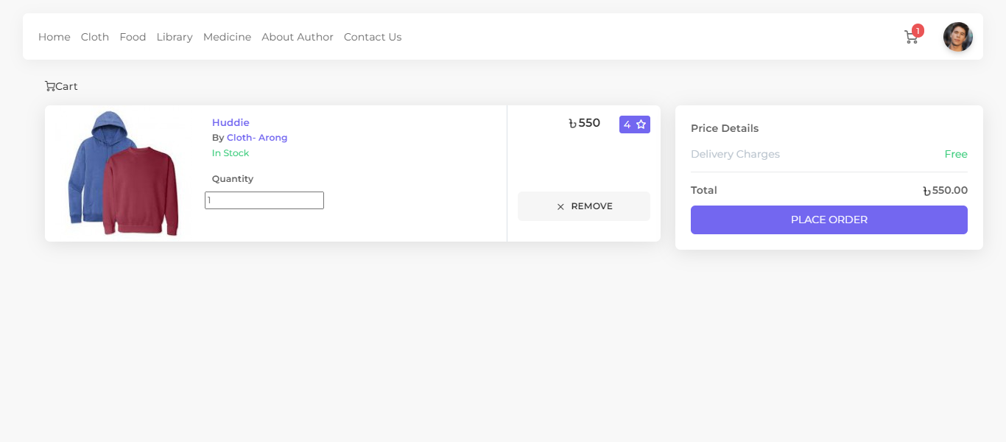

**8.2.5 Shipping Address**

In order to order the product, he must send the valid address

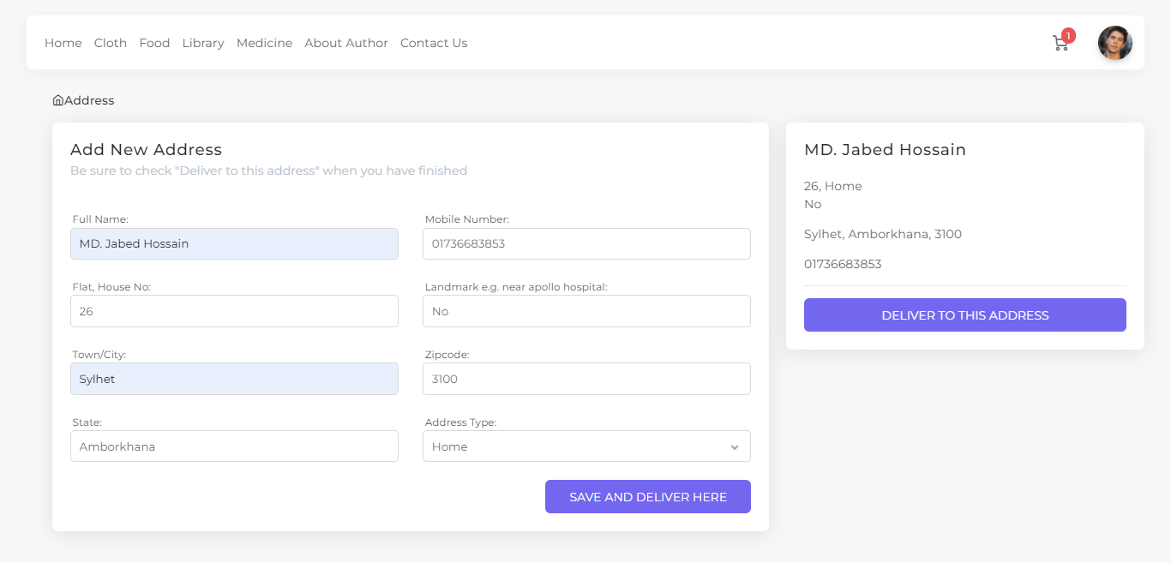

**8.2.6 Checkout**

He needs to checkout to make the order successful

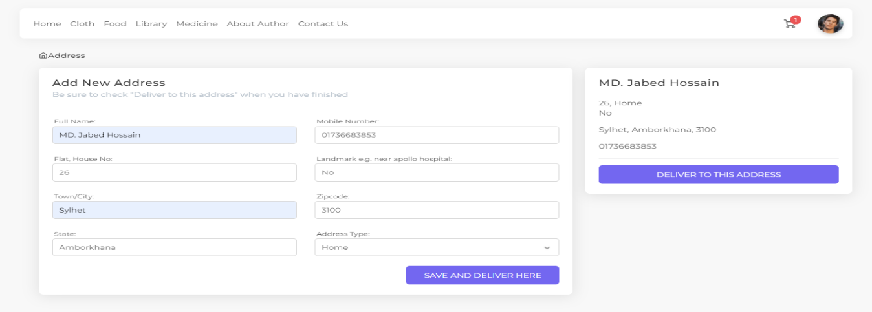

**8.3 Message**

Both the visitor and customer can send a message to the admin panel.

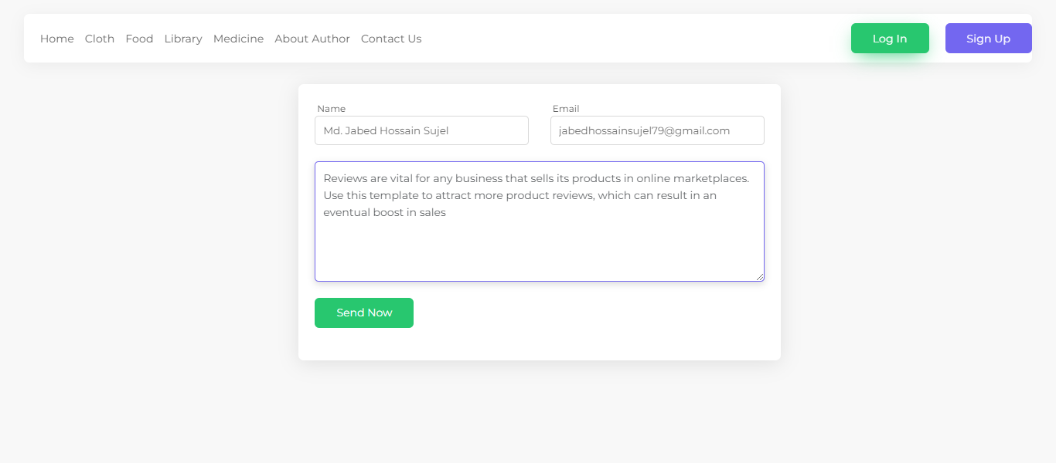

**8.4 About Authors**

Both the visitor and customer can see the author details.

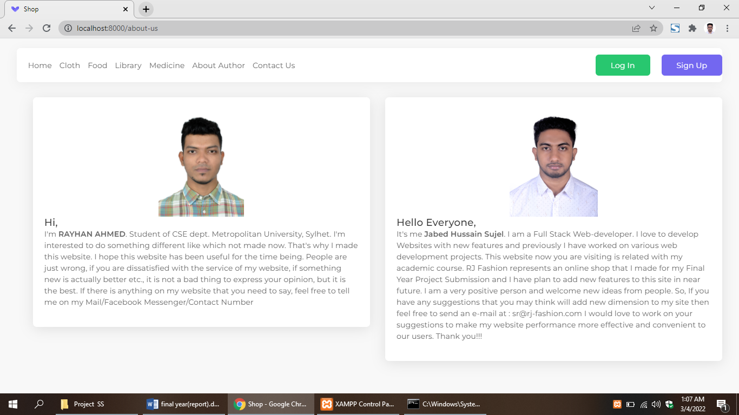

**8.5 Admin**

**8.5.1 Log In**

Admin has to login with correct email and password.

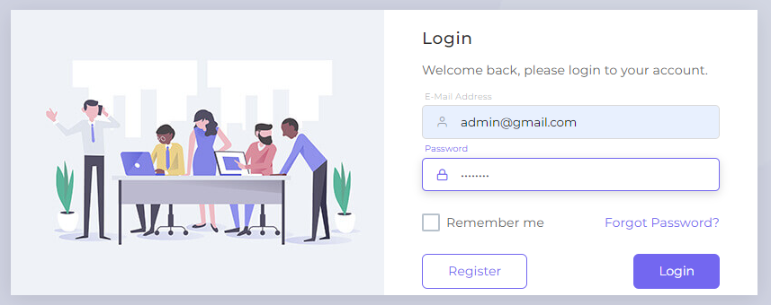

**8.5.2 Dashboard**

It will show the interface of how many orders, products, messages and categories there are.

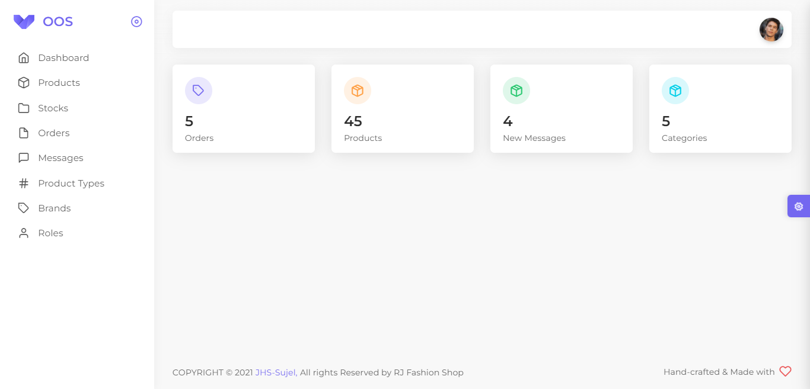

**8.5.3 Product’s**

This interface shows how many product there are and can be edited i.e. product activated and inactivated

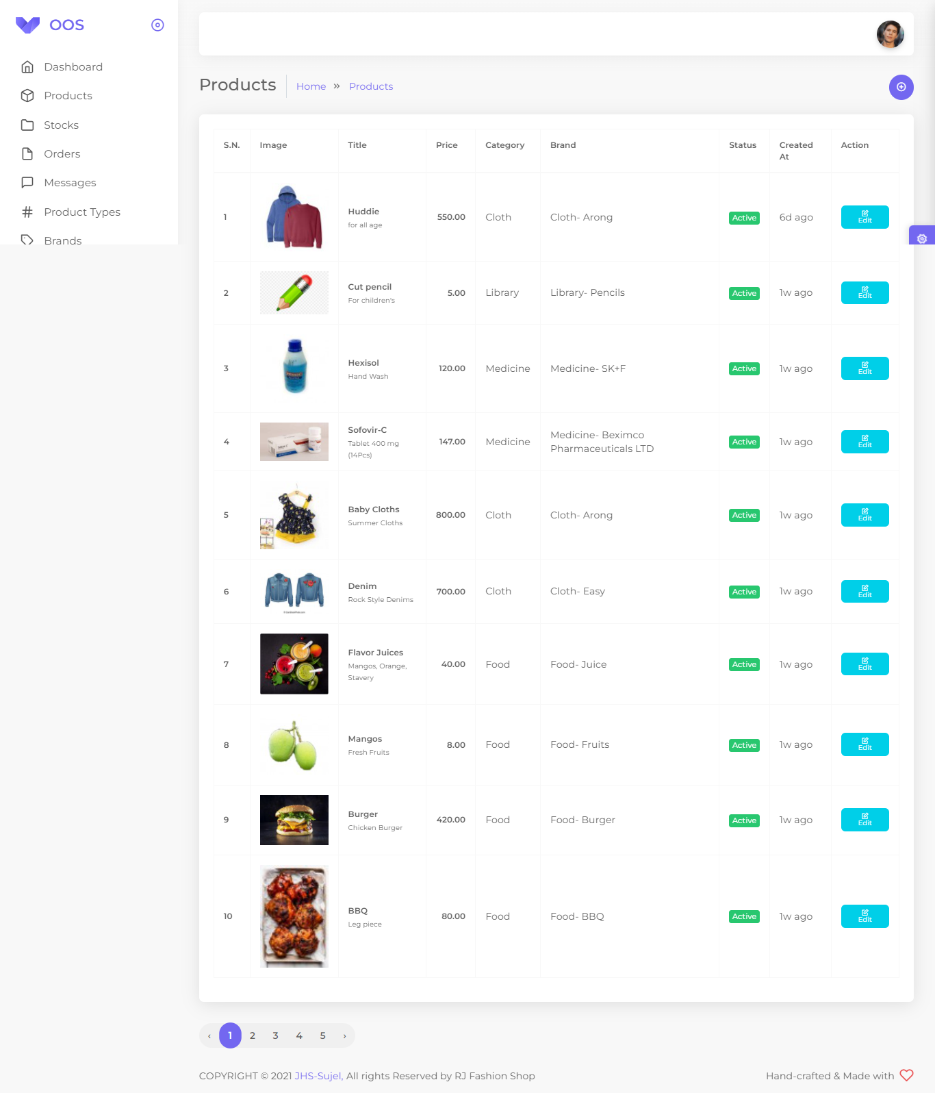

**8.5.4 Product Edit**

Admin can be edited products

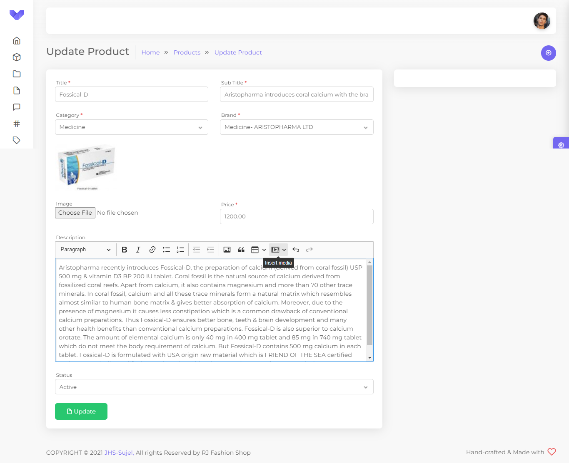

**8.5.5 Product Add**

With this interface, products can be added by their title, sub title, category, brand, image, price, description.

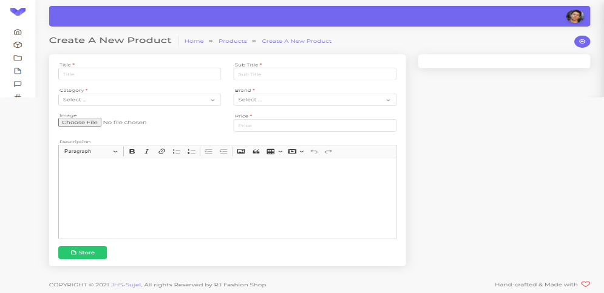

**8.5.6 Stocks**

When the products are added, the products have to be stocked to be displayed in the customer and visitor interface. Then the admin can edit them.

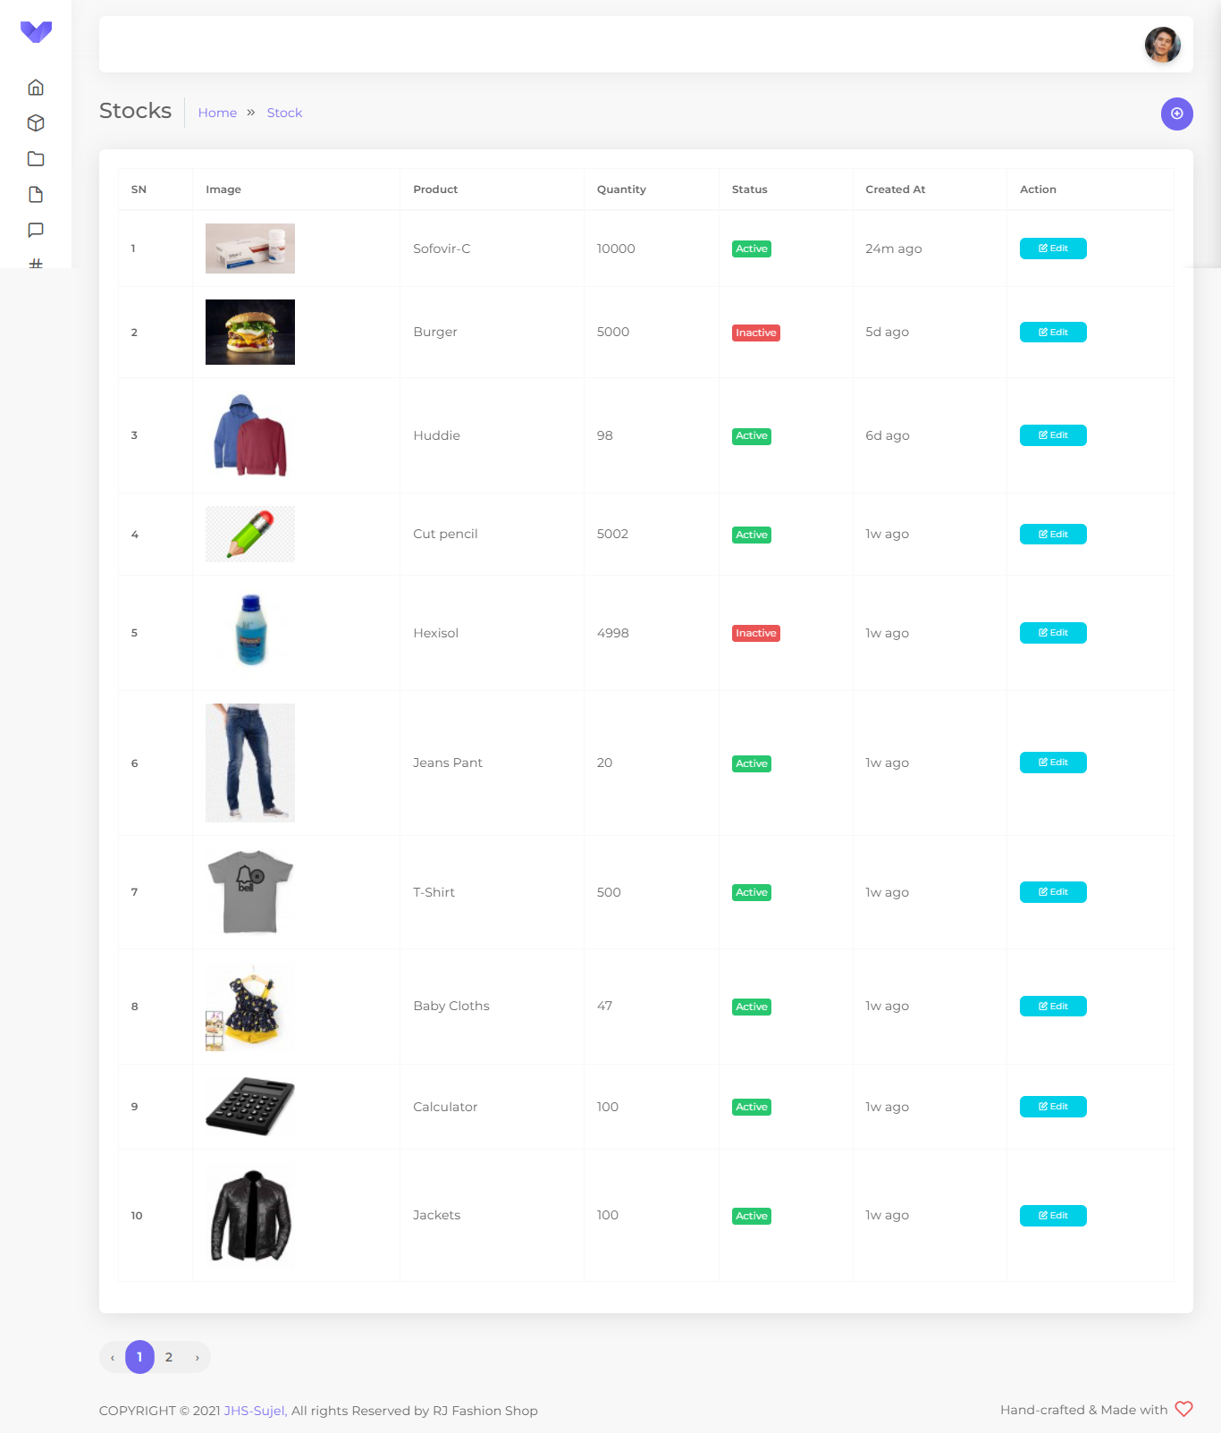

**8.5.7 Stock Edit**

Admin will be able to activate and inactivate the products from update stock

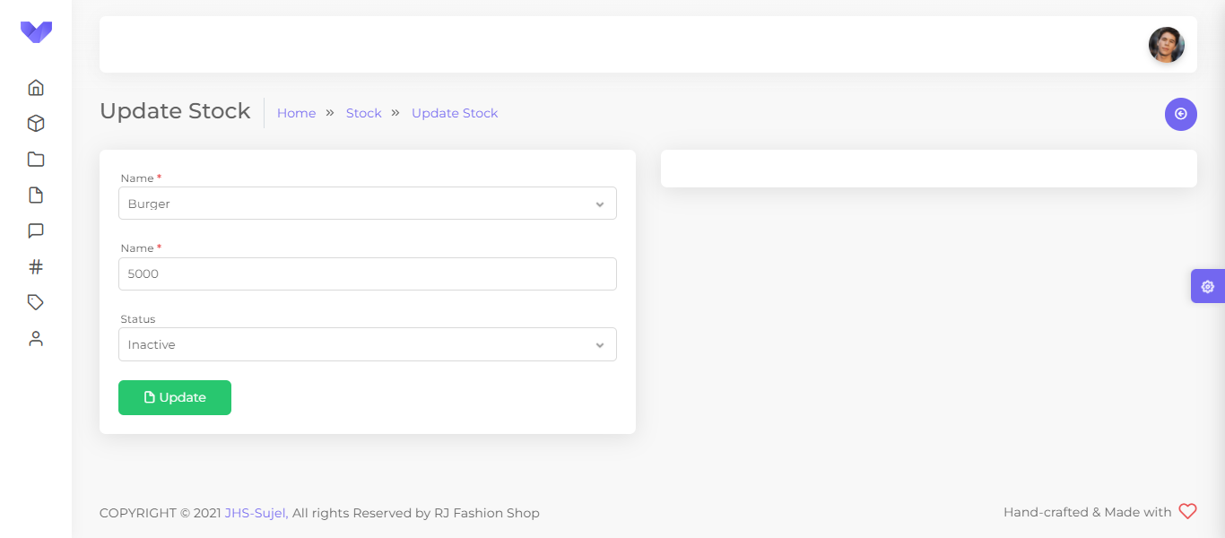

**8.5.8 Stock Add**

The products are named according to the name under which they were saved and the products are stocked with their quantity

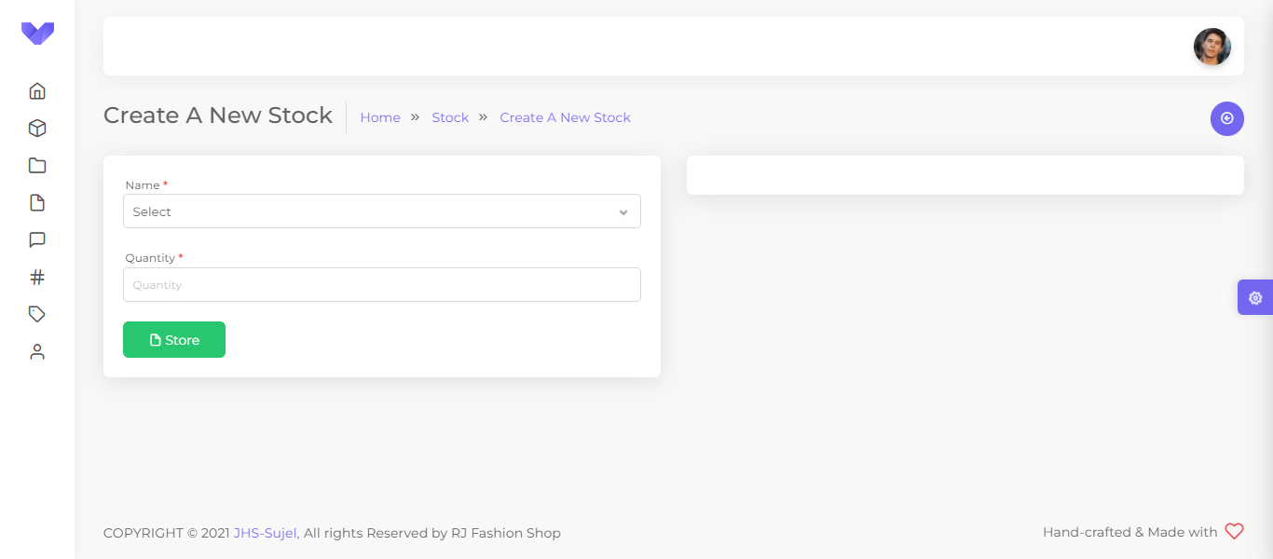

**8.5.9 Order's**

The admin will be able to see how many products the customer has ordered

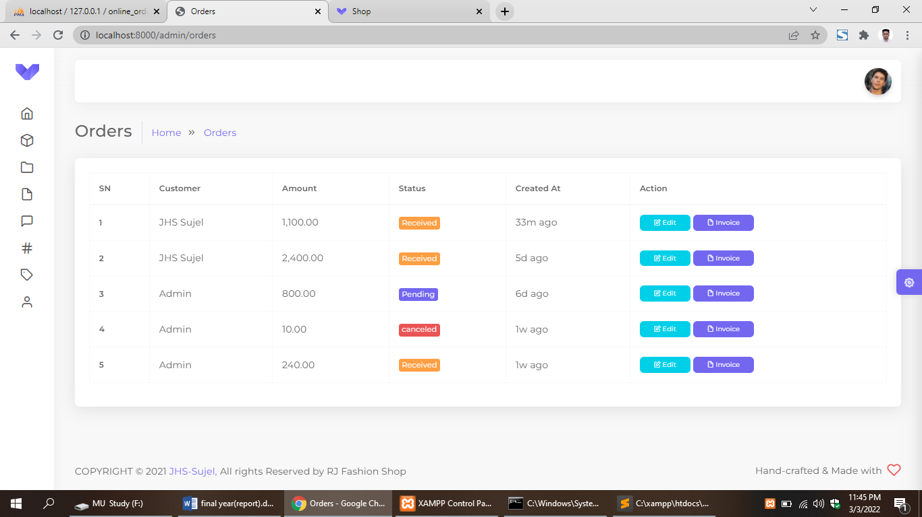

**8.5.10 Order Edit**

Admin will be able to cancel and confirm the order

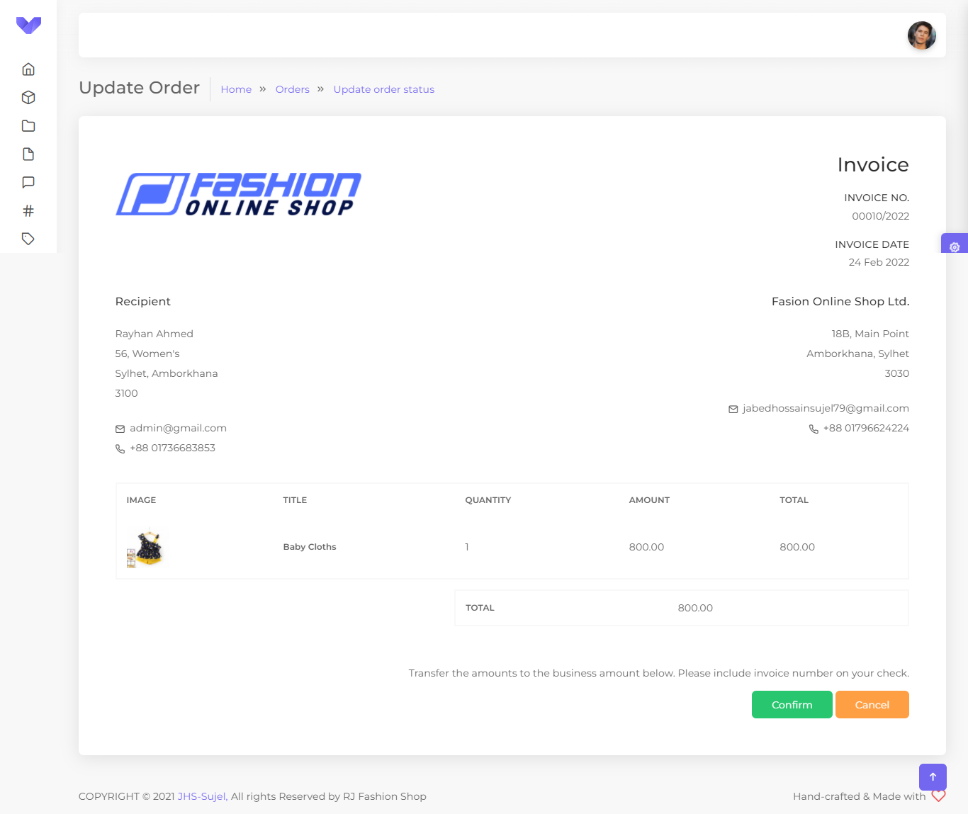

**8.5.11 Invoice**

Invoice will be given as document

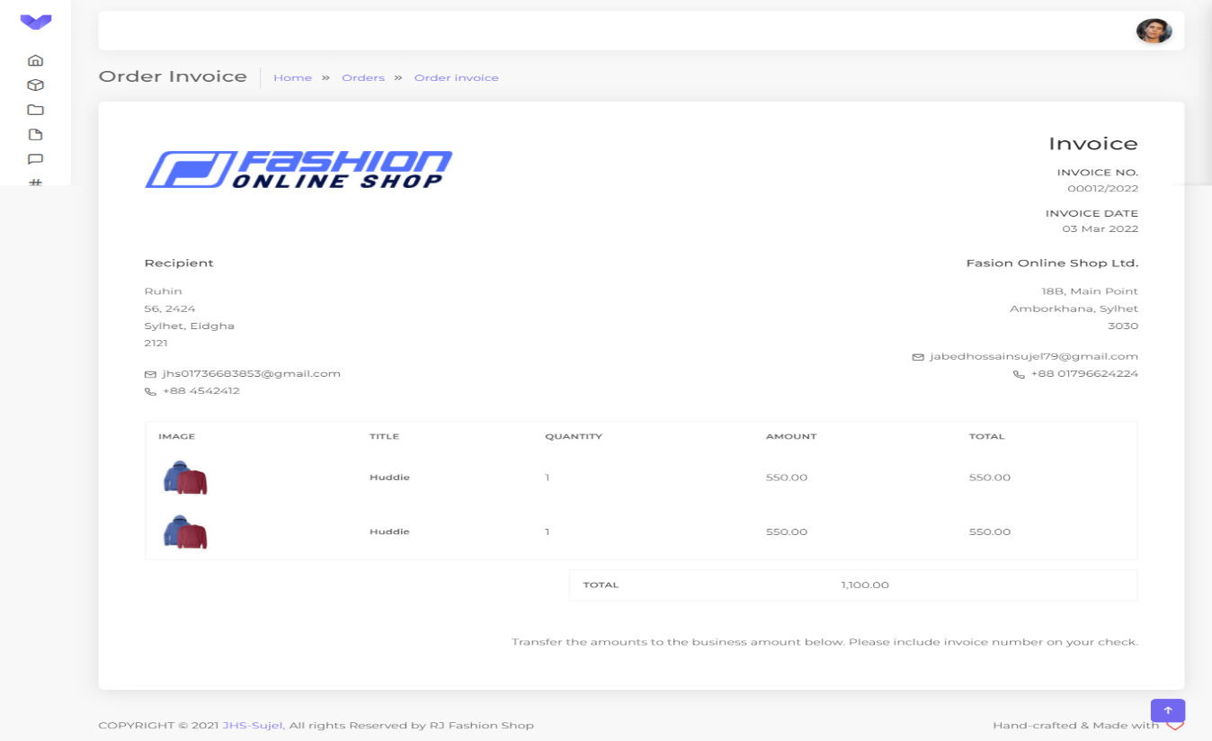

**8.5.12 Products Categories**

The admin will be able to see how many products categories there are

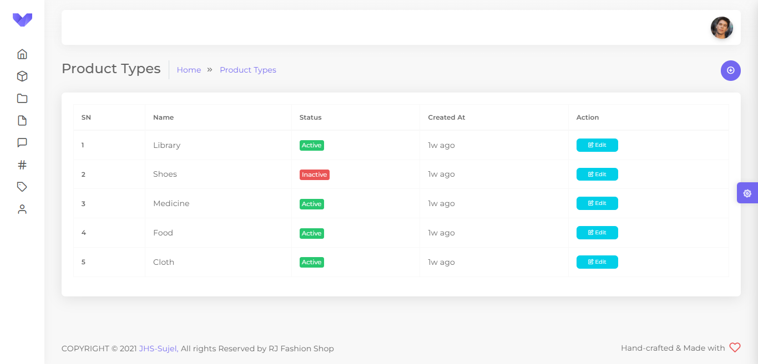

**8.5.13 Products Categories Edit**

Admin will be able to edit the product according to the category name and activate, inactivate them.

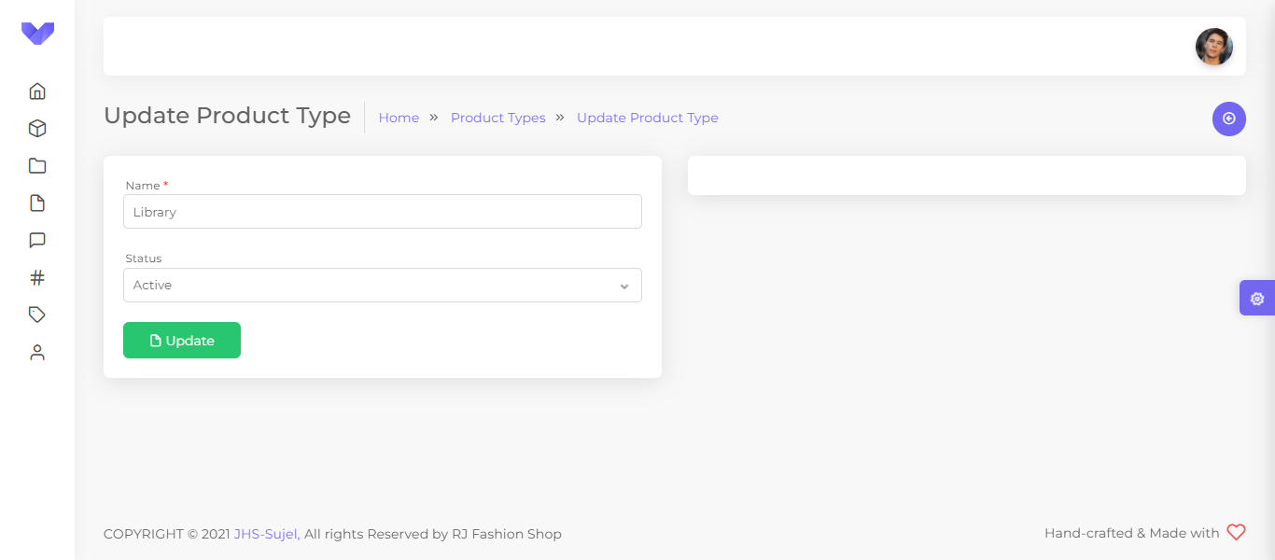

**8.5.14 Products Categories Add**

Admin will be able to add different categories according to the name of their categories

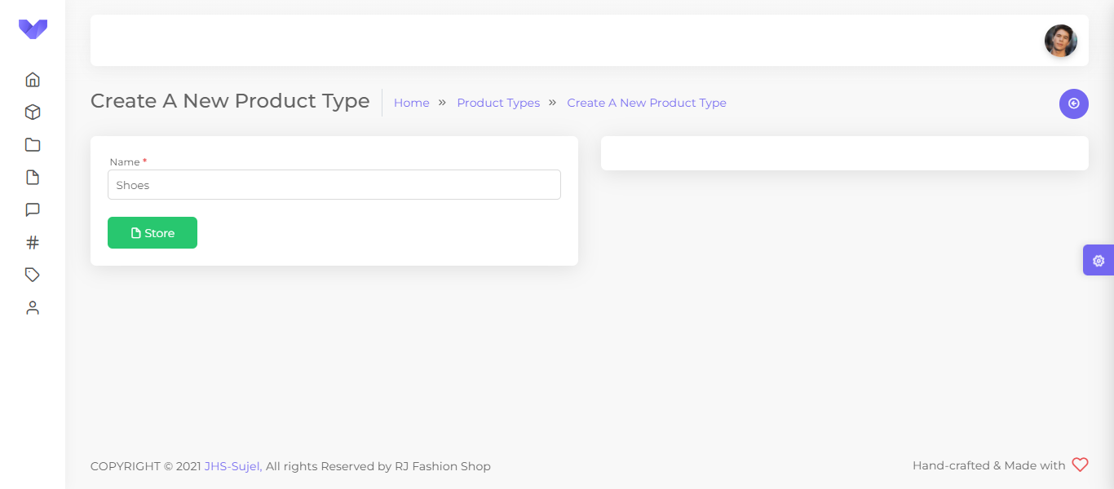

**8.5.15 Brands**

The admin will be able to see how many products brands there are

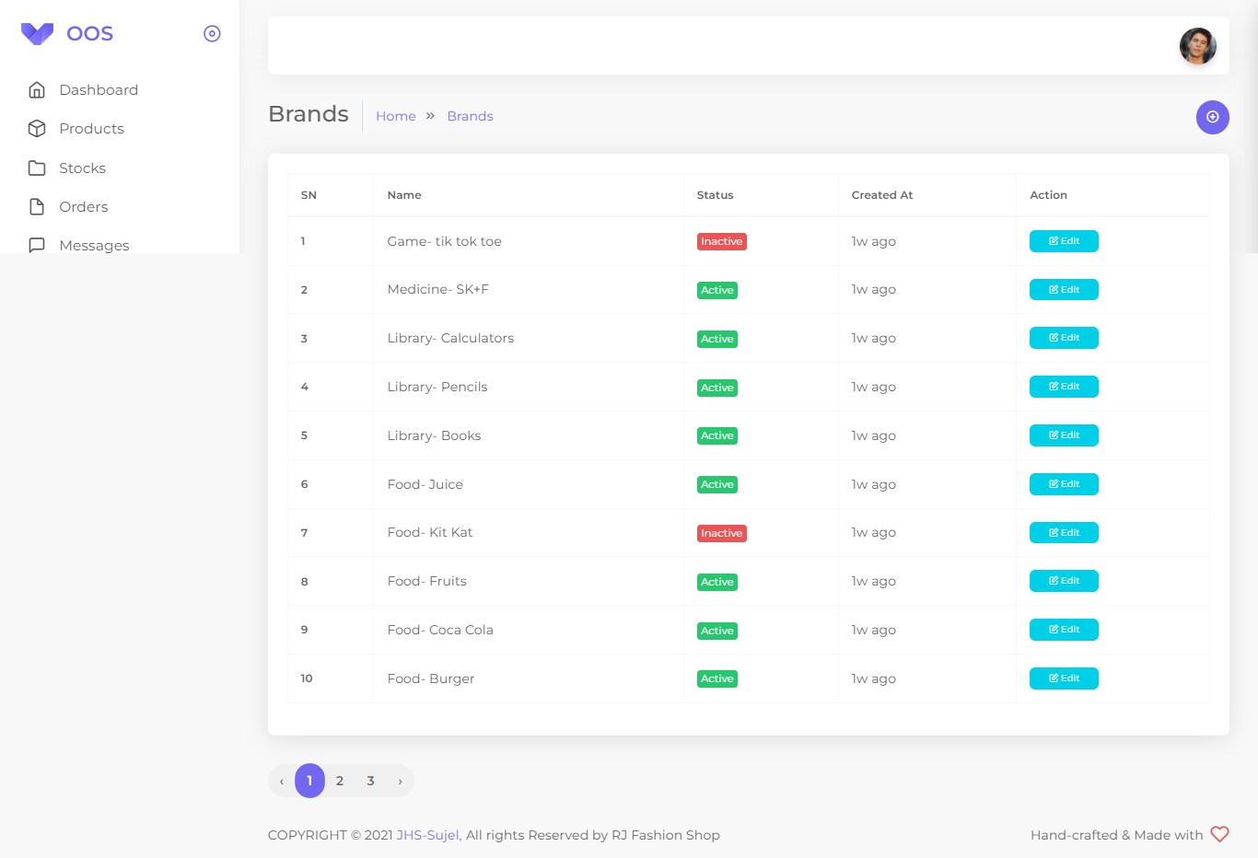

**8.5.16 Brands Edit**

Admin will be able to edit the product brands according to the brands name and activate, inactivate them.

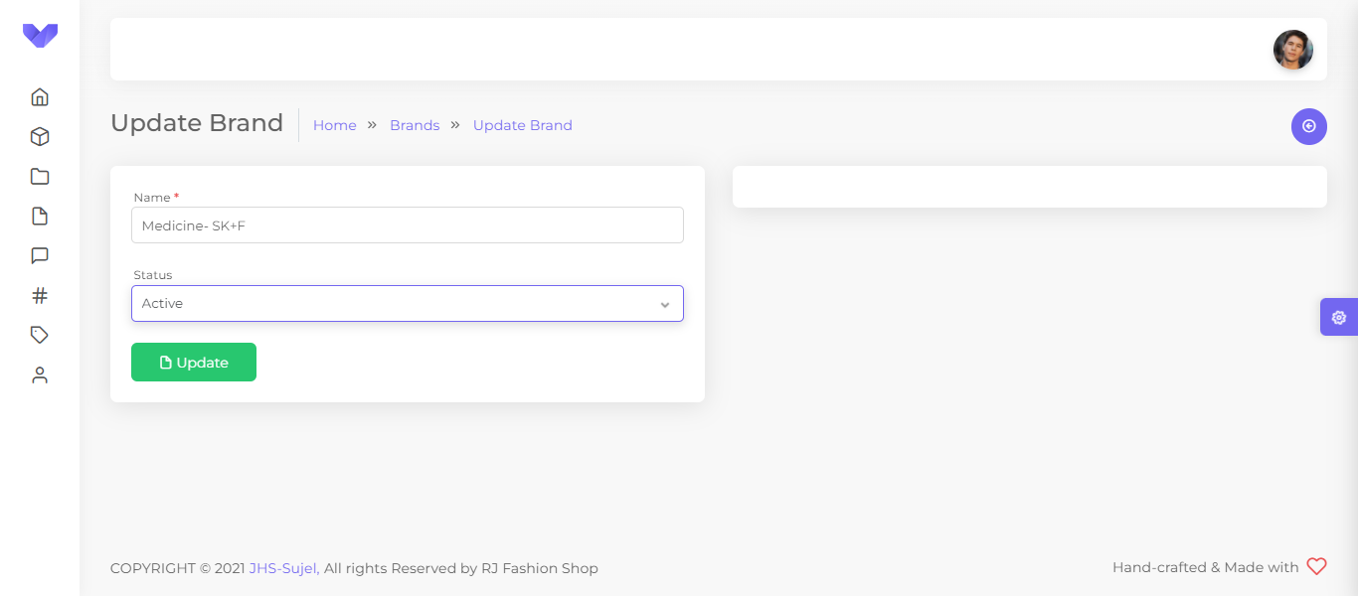

**8.5.17 Brands Add**

Admin will be able to add different brands according to the name of their brands

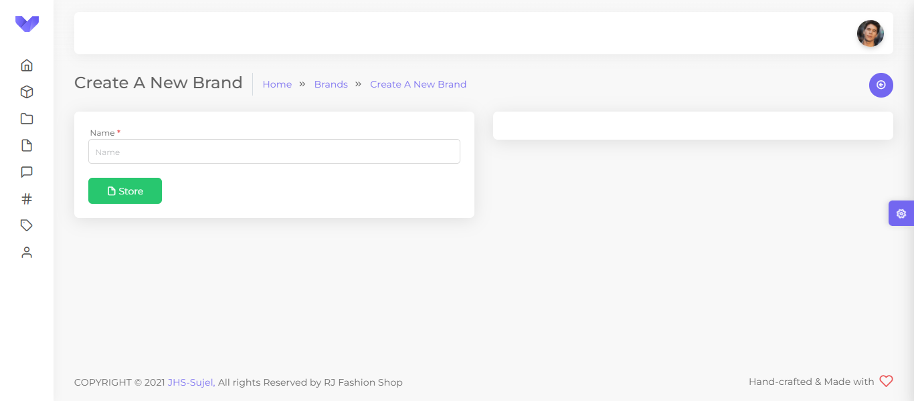

**8.5.18 Rules**

The admin will be able to see how many rules there are

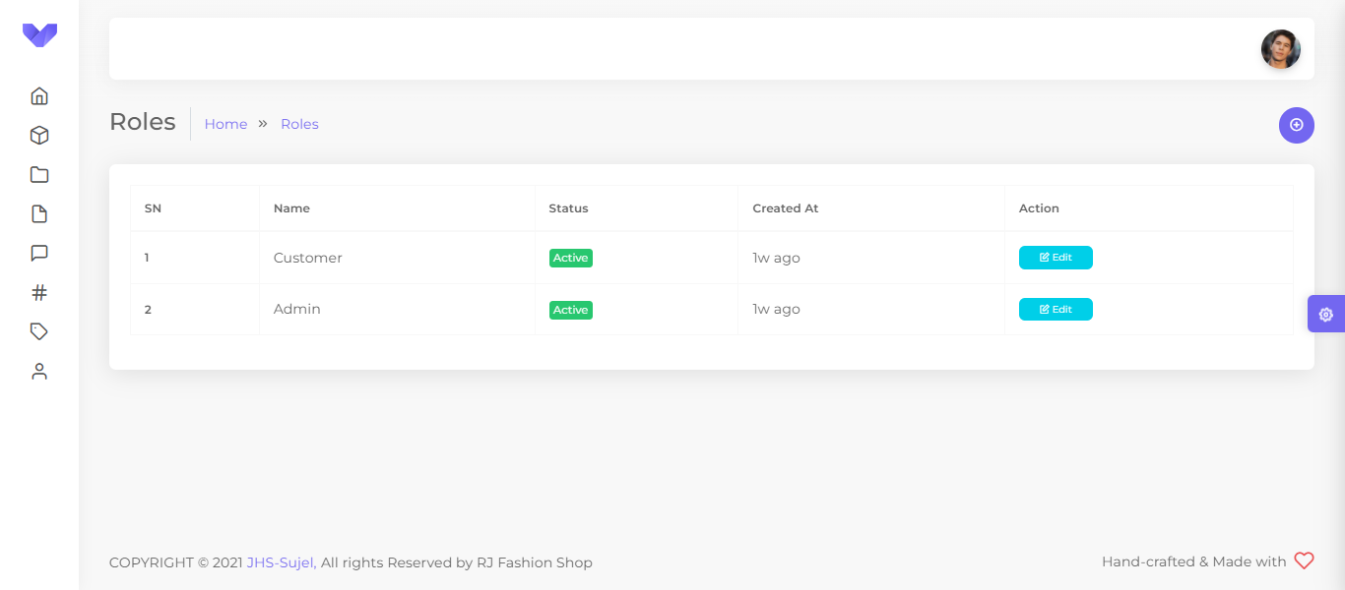

**8.5.19 Rules Edit**

Admin will be able to edit the rules according to the rules name and activate, inactivate them.

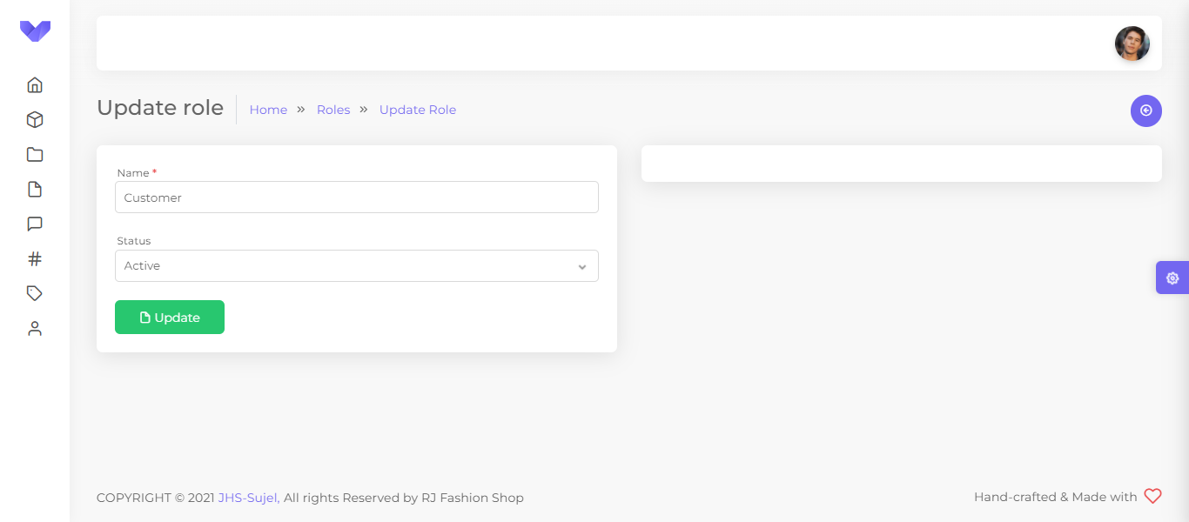

**8.5.20 Rules Add**

Admin will be able to add different rules according to the name of their rules

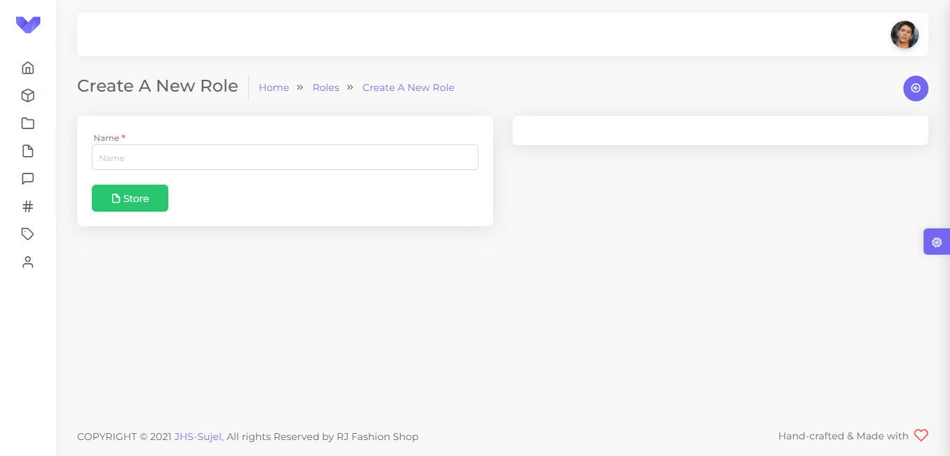

**8.5.21 Messages**

From this interface the admin can see how many messages have come from viewers and customers.

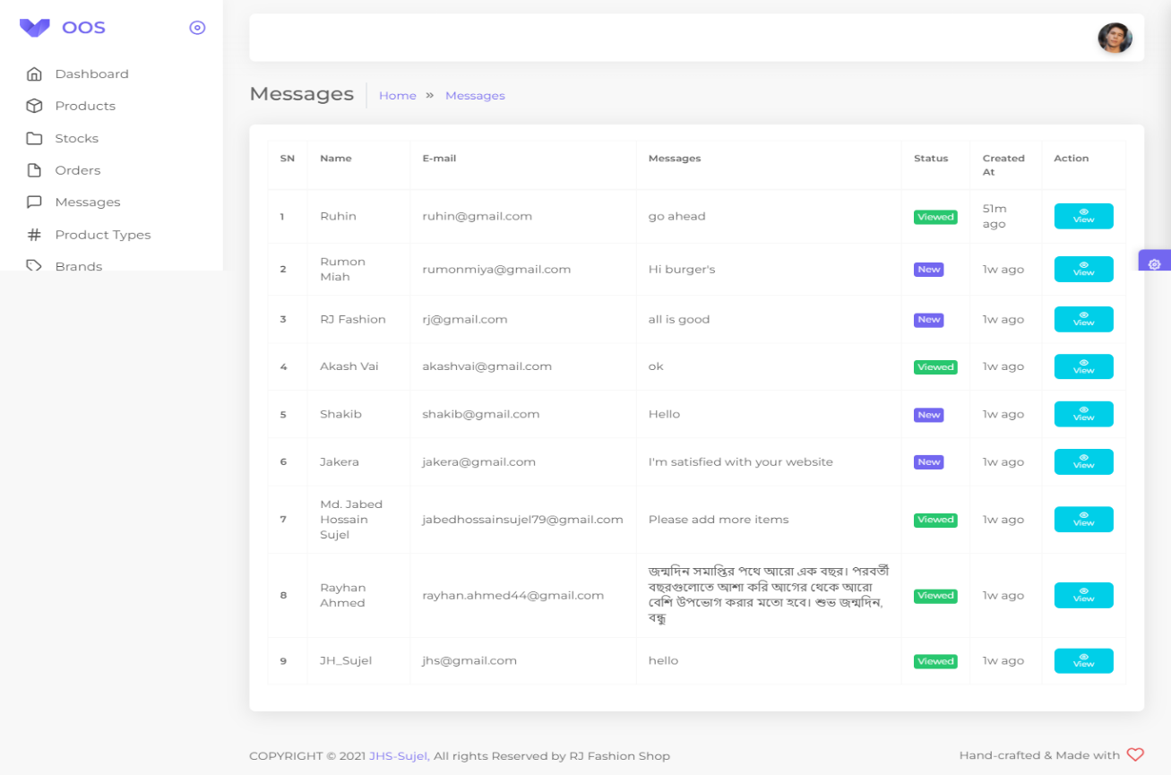

**8.5.22 Message View**

Admin will be able to see messages from viewers and customers.

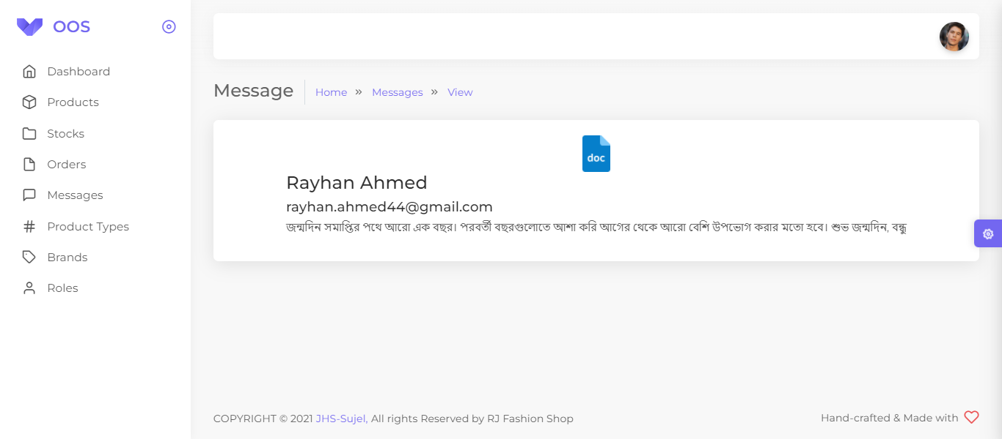

**Chapter 9**

**Future Plan**

**9.1 Future Plan**

The project has a very vast scope in future. The project can be implemented on intranet in future. Project can be updated in near future as and when requirement for the same arises, as it is very flexible in terms of expansion. With the proposed software of database Space Manager ready and fully functional the client is now able to manage and hence run the entire work in a much better, accurate and error free manner.

The following are the future scope for the project:

1. Want to Increase facilities of this project.
2. Want to develop graphical design.
3. Want to add credit card option when I will starting my business by domain help.
4. Want to publish this website in online.
5. Want to remove all the limitation.
6. Want to add a chat boot for users.
7. Want to add more filter for sorting.
8. Want to add group working facility.
9. Want to add Global payment processing system.
10. Want to add Global version for international clients.

**Chapter 10**

**Conclusion**

**10.1 Conclusion**

After having detail study on online shopping, we can see a great change in the behavior of people in many manners like their attitude, buying pattern. In earlier times people use to do manual shopping but now as time changed, people are becoming busy and due to which technology has brought a new revolution i.e. online shopping. As we started doing survey, it came to in notice that young age group people i.e. 15-30 uses of prefer online shopping because it is time and energy saving. But middle age group does not prefer much because they have wrong perception that by seeing the product one can get the goods of proper quality. And even some people does not prefer using plastic money i.e. credit cards.

But online shopping has a great future but to be successful it is necessary to spread awareness about its benefit.

**Reference**

**Book**

* Avisilberschatz, Henry F. Korth, S. Sudarshanby Database System Concepts, Sixth Edition Published by McGraw-Hill, ISBN-0-07-352332-1.
* John W. Satzinger, Robert B. Stephen, D. Burdby System Analysis and Design in a Changing World, 4th Edition written by, ISBN-10-1305117204
* Jeffrey D. Ullman and Jennifer Widomby First Courses in Database Systems, ISBN 0-13-861337-0
* Software Engineering, 8th edition by Sommerville.

**Web Browsing**

* <https://learn.vonage.com/blog/2017/07/26/2fa-logins-laravel-nexmo-dr/>
* <https://michaelheap.com/chatops-with-nexmo-verify/>
* <https://www.vonage.com/communications-apis/verify/?icid=nexmo_rd>
* <https://www.javatpoint.com/xampp>
* <https://www.educba.com/what-is-xampp/>
* <https://www.guru99.com/database-design.html>
* <https://github.com/>
* <https://www.npmjs.com/>
* <https://reactjs.org/>
* <https://developer.mozilla.org/en-US/>
* <https://fontawesome.com/>
* <https://react-bootstrap.github.io/>
* <https://stackoverflow.com/>
* <https://developer.nexmo.com/api/sms>
* <https://developer.vonage.com/messaging/sms/overview>
* <http://localhost:8000/> ( User Interface )
* <https://codeanddeploy.com/blog/laravel/laravel-8-sms-notification-with-vonage-api-example>
* <https://www.itsolutionstuff.com/post/laravel-send-sms-to-mobile-with-nexmo-exampleexample.html>
* <https://laravel.com/docs/9.x/verification>
* <https://laravel.com/>
* <https://www.google.com/>